Laporan Tugas Kecil 1 Kriptografi

1. Source Code

Src.py

import numpy as np

import re

def outputmaker(a):

    return ' '.join([a[i:i + 5] for i in range(0, len(a), 5)])

def keymaker(message,key):

    keychar = []

    if (len(message)>(len(key))):

        for i in range(len(message)):

            keychar.insert(len(keychar),ord(key[i%len(key)])%97)

    else:

        for characters in key:

            keychar.insert(len(keychar),ord(characters)%97)

    return keychar

def autokeymaker(message,key):

    keychar = []

    if (len(message)>(len(key))):

        for i in range(len(key)):

            keychar.insert(len(keychar),ord(key[i])%97)

        for i in range(len(key),len(message)):

            keychar.insert(len(keychar),ord(message[i-len(key)])%97)

    else:

        for characters in key:

            keychar.insert(len(keychar),ord(characters)%97)

    return keychar

def playfairkeymaker(key):

    key.replace('j','')

    keychar = []

    for i in range(len(key)):

        if (ord(key[i])%97) in keychar:

            continue

        else:

            keychar.insert(len(keychar),ord(key[i])%97)

    toInsert = 0

    while(len(keychar)<25):

        if (toInsert==9):

            toInsert += 1

            continue

        if (toInsert not in keychar):

            keychar.insert(len(keychar),toInsert)

        toInsert += 1

    pfkey = np.reshape(keychar,(5,5))

    return pfkey

'''def bytetextmaker(file):

    byte = file.read(1)

    textchar = []

    while byte:

        textchar.insert(len(textchar),ord(byte))

        byte = file.read(1)

    return textchar'''

def playfairtextmaker(message):

    message.replace('j','i')

    messagechar = []

    for characters in message:

        messagechar.insert(len(messagechar),ord(characters)%97)

    for i in range(1,len(messagechar)):

        if (messagechar[i]==messagechar[i-1]):

            messagechar.insert(i,23)

    if (len(messagechar)%2==1):

        messagechar.insert(len(messagechar),23)

    pftext = np.reshape(messagechar,(-1,2))

    return pftext

def vigenere_encrypt(message,key):

    keychar = keymaker(message,key)

    messagechar = []

    for characters in message:

        messagechar.insert(len(messagechar),ord(characters)%97)

    encrypted = messagechar

    for i in range(len(encrypted)):

        encrypted[i] = vigenere_matrice[keychar[i]][messagechar[i]]

    return encrypted

def full_vigenere_encrypt(message,key):

    np.random.shuffle(full_vigenere_matrice)

    keychar = keymaker(message,key)

    messagechar = []

    for characters in message:

        messagechar.insert(len(messagechar),ord(characters)%97)

    encrypted = messagechar

    for i in range(len(encrypted)):

        encrypted[i] = full_vigenere_matrice[keychar[i]][messagechar[i]]

    return encrypted

def autokey_vigenere_encrypt(message,key):

    keychar = autokeymaker(message,key)

    messagechar = []

    for characters in message:

        messagechar.insert(len(messagechar),ord(characters)%97)

    encrypted = messagechar

    for i in range(len(encrypted)):

        encrypted[i] = vigenere_matrice[keychar[i]][messagechar[i]]

    return encrypted

'''def extended_vigenere_encrypt(message,key):'''

def playfair_calculate(row,pfkey,encrypt):

    position_matrice = np.zeros((2,2), dtype=int)

    x, y, i, j, loop = 0, 0, 0, 0, 0

    while(loop!=2):

        if (j==5):

            i += 1

            j = -1

        elif (pfkey[i][j]==row[loop]):

            position_matrice[x][y] = i

            y += 1

            position_matrice[x][y] = j

            x += 1

            y, i, j = 0, 0, -1

            loop += 1

        j += 1

    if (encrypt):

        if (position_matrice[0][0]==position_matrice[1][0]):

            position_matrice[0][1] = (position_matrice[0][1] + 1) % 5

            position_matrice[1][1] = (position_matrice[1][1] + 1) % 5

        elif (position_matrice[0][1]==position_matrice[1][1]):

            position_matrice[0][0] = (position_matrice[0][0] + 1) % 5

            position_matrice[1][0] = (position_matrice[1][0] + 1) % 5

        else:

            swap = position_matrice[0][1]

            position_matrice[0][1] = position_matrice[1][1]

            position_matrice[1][1] = swap

    else:

        if (position_matrice[0][0]==position_matrice[1][0]):

            position_matrice[0][1] = (position_matrice[0][1] - 1) % 5

            position_matrice[1][1] = (position_matrice[1][1] - 1) % 5

        elif (position_matrice[0][1]==position_matrice[1][1]):

            position_matrice[0][0] = (position_matrice[0][0] - 1) % 5

            position_matrice[1][0] = (position_matrice[1][0] - 1) % 5

        else:

            swap = position_matrice[0][1]

            position_matrice[0][1] = position_matrice[1][1]

            position_matrice[1][1] = swap

    newrow = row

    newrow[0] = pfkey[position_matrice[0][0]][position_matrice[0][1]]

    newrow[1] = pfkey[position_matrice[1][0]][position_matrice[1][1]]

    return newrow

def playfair(pftext,pfkey,encrypt):

    procctext = pftext

    for i in range(len(pftext)):

        procctext[i] = playfair_calculate(pftext[i],pfkey,encrypt)

    result = np.reshape(procctext,procctext.size)

    return result

def affine_encrypt(message,m,b):

    encryptchar = []

    for characters in message:

        encryptchar.insert(len(encryptchar),(((ord(characters)%97)*m)+b)%26)

    return encryptchar

def vigenere_decrypt(message,key):

    keychar = keymaker(message,key)

    messagechar = []

    for characters in message:

        messagechar.insert(len(messagechar),ord(characters)%97)

    decrypted = messagechar

    for i in range(len(decrypted)):

        decrypted[i] = vigenere_matrice[(keychar[i]*-1)%26][messagechar[i]]

    return decrypted

def full_vigenere_decrypt(message,key):

    keychar = keymaker(message,key)

    messagechar = []

    for characters in message:

        messagechar.insert(len(messagechar),ord(characters)%97)

    decrypted = messagechar

    for i in range(len(decrypted)):

        for j in range(26):

            if(messagechar[i]==full_vigenere_matrice[keychar[i]][j]):

                decrypted[i] = j

                break

    return decrypted

def autokey_vigenere_decrypt(plaintext,message,key):

    keychar = autokeymaker(plaintext,key)

    messagechar = []

    for characters in message:

        messagechar.insert(len(messagechar),ord(characters)%97)

    decrypted = messagechar

    for i in range(len(decrypted)):

        for j in range(26):

            if(messagechar[i]==vigenere_matrice[keychar[i]][j]):

                decrypted[i] = j

                break

    return decrypted

def inverse_mod(base,m):

    for i in range(1,base):

        if (((i*m)%base)==1):

            return i

def affine_decrypt(message,m,b):

    decryptchar = []

    for characters in message:

        decryptchar.insert(len(decryptchar),((inverse_mod(26,m)*((ord(characters)%97)-b))%26))

    return decryptchar

vigenere_matrice = \

    np.array([[0,1,2,3,4,5,6,7,8,9,10,11,12,13,14,15,16,17,18,19,20,21,22,23,24,25],

              [1,2,3,4,5,6,7,8,9,10,11,12,13,14,15,16,17,18,19,20,21,22,23,24,25,0],

              [2,3,4,5,6,7,8,9,10,11,12,13,14,15,16,17,18,19,20,21,22,23,24,25,0,1],

              [3,4,5,6,7,8,9,10,11,12,13,14,15,16,17,18,19,20,21,22,23,24,25,0,1,2],

              [4,5,6,7,8,9,10,11,12,13,14,15,16,17,18,19,20,21,22,23,24,25,0,1,2,3],

              [5,6,7,8,9,10,11,12,13,14,15,16,17,18,19,20,21,22,23,24,25,0,1,2,3,4],

              [6,7,8,9,10,11,12,13,14,15,16,17,18,19,20,21,22,23,24,25,0,1,2,3,4,5],

              [7,8,9,10,11,12,13,14,15,16,17,18,19,20,21,22,23,24,25,0,1,2,3,4,5,6],

              [8,9,10,11,12,13,14,15,16,17,18,19,20,21,22,23,24,25,0,1,2,3,4,5,6,7],

              [9,10,11,12,13,14,15,16,17,18,19,20,21,22,23,24,25,0,1,2,3,4,5,6,7,8],

              [10,11,12,13,14,15,16,17,18,19,20,21,22,23,24,25,0,1,2,3,4,5,6,7,8,9],

              [11,12,13,14,15,16,17,18,19,20,21,22,23,24,25,0,1,2,3,4,5,6,7,8,9,10],

              [12,13,14,15,16,17,18,19,20,21,22,23,24,25,0,1,2,3,4,5,6,7,8,9,10,11],

              [13,14,15,16,17,18,19,20,21,22,23,24,25,0,1,2,3,4,5,6,7,8,9,10,11,12],

              [14,15,16,17,18,19,20,21,22,23,24,25,0,1,2,3,4,5,6,7,8,9,10,11,12,14],

              [15,16,17,18,19,20,21,22,23,24,25,0,1,2,3,4,5,6,7,8,9,10,11,12,14,15],

              [16,17,18,19,20,21,22,23,24,25,0,1,2,3,4,5,6,7,8,9,10,11,12,14,15,16],

              [17,18,19,20,21,22,23,24,25,0,1,2,3,4,5,6,7,8,9,10,11,12,13,14,15,16],

              [18,19,20,21,22,23,24,25,0,1,2,3,4,5,6,7,8,9,10,11,12,13,14,15,16,17],

              [19,20,21,22,23,24,25,0,1,2,3,4,5,6,7,8,9,10,11,12,13,14,15,16,17,18],

              [20,21,22,23,24,25,0,1,2,3,4,5,6,7,8,9,10,11,12,13,14,15,16,17,18,19],

              [21,22,23,24,25,0,1,2,3,4,5,6,7,8,9,10,11,12,13,14,15,16,17,18,19,20],

              [22,23,24,25,0,1,2,3,4,5,6,7,8,9,10,11,12,13,14,15,16,17,18,19,20,21],

              [23,24,25,0,1,2,3,4,5,6,7,8,9,10,11,12,13,14,15,16,17,18,19,20,21,22],

              [24,25,0,1,2,3,4,5,6,7,8,9,10,11,12,13,14,15,16,17,18,19,20,21,22,23],

              [25,0,1,2,3,4,5,6,7,8,9,10,11,12,13,14,15,16,17,18,19,20,21,22,23,24]])

full_vigenere_matrice = vigenere_matrice

''' akses matriks vigenere, vigenere_matrice[kunci][plainteks]'''

def playfairkeymaker(key):

    key.replace('j','')

    keychar = []

    for i in range(len(key)):

        if (ord(key[i])%97) in keychar:

            continue

        else:

            keychar.insert(len(keychar),ord(key[i])%97)

    toInsert = 0

    while(len(keychar)<25):

        if (toInsert==9):

            toInsert += 1

            continue

        if (toInsert not in keychar):

            keychar.insert(len(keychar),toInsert)

        toInsert += 1

    pfkey = np.reshape(keychar,(5,5))

    return pfkey

def playfairtextmaker(message):

    message.replace('j','i')

    messagechar = []

    for characters in message:

        messagechar.insert(len(messagechar),ord(characters)%97)

    for i in range(1,len(messagechar)):

        if (messagechar[i]==messagechar[i-1]):

            messagechar.insert(i,23)

    if (len(messagechar)%2==1):

        messagechar.insert(len(messagechar),23)

    pftext = np.reshape(messagechar,(-1,2))

    return pftext

def vigenere_encrypt(message,key):

    keychar = keymaker(message,key)

    messagechar = []

    for characters in message:

        messagechar.insert(len(messagechar),ord(characters)%97)

    encrypted = messagechar

    for i in range(len(encrypted)):

        encrypted[i] = vigenere_matrice[keychar[i]][messagechar[i]]

    return encrypted

def full_vigenere_encrypt(message,key):

    np.random.shuffle(full_vigenere_matrice)

    keychar = keymaker(message,key)

    messagechar = []

    for characters in message:

        messagechar.insert(len(messagechar),ord(characters)%97)

    encrypted = messagechar

    for i in range(len(encrypted)):

        encrypted[i] = full_vigenere_matrice[keychar[i]][messagechar[i]]

    return encrypted

def autokey_vigenere_encrypt(message,key):

    keychar = autokeymaker(message,key)

    messagechar = []

    for characters in message:

        messagechar.insert(len(messagechar),ord(characters)%97)

    encrypted = messagechar

    for i in range(len(encrypted)):

        encrypted[i] = vigenere_matrice[keychar[i]][messagechar[i]]

    return encrypted

'''def extended_vigenere_encrypt(message,key):'''

def playfair_calculate(row,pfkey,encrypt):

    position_matrice = np.zeros((2,2), dtype=int)

    x, y, i, j, loop = 0, 0, 0, 0, 0

    while(loop!=2):

        if (j==5):

            i += 1

            j = -1

        elif (pfkey[i][j]==row[loop]):

            position_matrice[x][y] = i

            y += 1

            position_matrice[x][y] = j

            x += 1

            y, i, j = 0, 0, -1

            loop += 1

        j += 1

    if (encrypt):

        if (position_matrice[0][0]==position_matrice[1][0]):

            position_matrice[0][1] = (position_matrice[0][1] + 1) % 5

            position_matrice[1][1] = (position_matrice[1][1] + 1) % 5

        elif (position_matrice[0][1]==position_matrice[1][1]):

            position_matrice[0][0] = (position_matrice[0][0] + 1) % 5

            position_matrice[1][0] = (position_matrice[1][0] + 1) % 5

        else:

            swap = position_matrice[0][1]

            position_matrice[0][1] = position_matrice[1][1]

            position_matrice[1][1] = swap

    else:

        if (position_matrice[0][0]==position_matrice[1][0]):

            position_matrice[0][1] = (position_matrice[0][1] - 1) % 5

            position_matrice[1][1] = (position_matrice[1][1] - 1) % 5

        elif (position_matrice[0][1]==position_matrice[1][1]):

            position_matrice[0][0] = (position_matrice[0][0] - 1) % 5

            position_matrice[1][0] = (position_matrice[1][0] - 1) % 5

        else:

            swap = position_matrice[0][1]

            position_matrice[0][1] = position_matrice[1][1]

            position_matrice[1][1] = swap

    newrow = row

    newrow[0] = pfkey[position_matrice[0][0]][position_matrice[0][1]]

    newrow[1] = pfkey[position_matrice[1][0]][position_matrice[1][1]]

    return newrow

def playfair(pftext,pfkey,encrypt):

    procctext = pftext

    for i in range(len(pftext)):

        procctext[i] = playfair_calculate(pftext[i],pfkey,encrypt)

    result = np.reshape(procctext,procctext.size)

    return result

def affine_encrypt(message,m,b):

    encryptchar = []

    for characters in message:

        encryptchar.insert(len(encryptchar),(((ord(characters)%97)*m)+b)%26)

    return encryptchar

def vigenere_decrypt(message,key):

    keychar = keymaker(message,key)

    messagechar = []

    for characters in message:

        messagechar.insert(len(messagechar),ord(characters)%97)

    decrypted = messagechar

    for i in range(len(decrypted)):

        decrypted[i] = vigenere_matrice[(keychar[i]*-1)%26][messagechar[i]]

    return decrypted

def full_vigenere_decrypt(message,key):

    keychar = keymaker(message,key)

    messagechar = []

    for characters in message:

        messagechar.insert(len(messagechar),ord(characters)%97)

    decrypted = messagechar

    for i in range(len(decrypted)):

        for j in range(26):

            if(messagechar[i]==full_vigenere_matrice[keychar[i]][j]):

                decrypted[i] = j

                break

    return decrypted

def autokey_vigenere_decrypt(plaintext,message,key):

    keychar = autokeymaker(plaintext,key)

    messagechar = []

    for characters in message:

        messagechar.insert(len(messagechar),ord(characters)%97)

    decrypted = messagechar

    for i in range(len(decrypted)):

        for j in range(26):

            if(messagechar[i]==vigenere_matrice[keychar[i]][j]):

                decrypted[i] = j

                break

    return decrypted

def inverse_mod(base,m):

    for i in range(1,base):

        if (((i*m)%base)==1):

            return i

def affine_decrypt(message,m,b):

    decryptchar = []

    for characters in message:

        decryptchar.insert(len(decryptchar),((inverse_mod(26,m)*((ord(characters)%97)-b))%26))

    return decryptchar

vigenere_matrice = \

    np.array([[0,1,2,3,4,5,6,7,8,9,10,11,12,13,14,15,16,17,18,19,20,21,22,23,24,25],

              [1,2,3,4,5,6,7,8,9,10,11,12,13,14,15,16,17,18,19,20,21,22,23,24,25,0],

              [2,3,4,5,6,7,8,9,10,11,12,13,14,15,16,17,18,19,20,21,22,23,24,25,0,1],

              [3,4,5,6,7,8,9,10,11,12,13,14,15,16,17,18,19,20,21,22,23,24,25,0,1,2],

              [4,5,6,7,8,9,10,11,12,13,14,15,16,17,18,19,20,21,22,23,24,25,0,1,2,3],

              [5,6,7,8,9,10,11,12,13,14,15,16,17,18,19,20,21,22,23,24,25,0,1,2,3,4],

              [6,7,8,9,10,11,12,13,14,15,16,17,18,19,20,21,22,23,24,25,0,1,2,3,4,5],

              [7,8,9,10,11,12,13,14,15,16,17,18,19,20,21,22,23,24,25,0,1,2,3,4,5,6],

              [8,9,10,11,12,13,14,15,16,17,18,19,20,21,22,23,24,25,0,1,2,3,4,5,6,7],

              [9,10,11,12,13,14,15,16,17,18,19,20,21,22,23,24,25,0,1,2,3,4,5,6,7,8],

              [10,11,12,13,14,15,16,17,18,19,20,21,22,23,24,25,0,1,2,3,4,5,6,7,8,9],

              [11,12,13,14,15,16,17,18,19,20,21,22,23,24,25,0,1,2,3,4,5,6,7,8,9,10],

              [12,13,14,15,16,17,18,19,20,21,22,23,24,25,0,1,2,3,4,5,6,7,8,9,10,11],

              [13,14,15,16,17,18,19,20,21,22,23,24,25,0,1,2,3,4,5,6,7,8,9,10,11,12],

              [14,15,16,17,18,19,20,21,22,23,24,25,0,1,2,3,4,5,6,7,8,9,10,11,12,14],

              [15,16,17,18,19,20,21,22,23,24,25,0,1,2,3,4,5,6,7,8,9,10,11,12,14,15],

              [16,17,18,19,20,21,22,23,24,25,0,1,2,3,4,5,6,7,8,9,10,11,12,14,15,16],

              [17,18,19,20,21,22,23,24,25,0,1,2,3,4,5,6,7,8,9,10,11,12,13,14,15,16],

              [18,19,20,21,22,23,24,25,0,1,2,3,4,5,6,7,8,9,10,11,12,13,14,15,16,17],

              [19,20,21,22,23,24,25,0,1,2,3,4,5,6,7,8,9,10,11,12,13,14,15,16,17,18],

              [20,21,22,23,24,25,0,1,2,3,4,5,6,7,8,9,10,11,12,13,14,15,16,17,18,19],

              [21,22,23,24,25,0,1,2,3,4,5,6,7,8,9,10,11,12,13,14,15,16,17,18,19,20],

              [22,23,24,25,0,1,2,3,4,5,6,7,8,9,10,11,12,13,14,15,16,17,18,19,20,21],

              [23,24,25,0,1,2,3,4,5,6,7,8,9,10,11,12,13,14,15,16,17,18,19,20,21,22],

              [24,25,0,1,2,3,4,5,6,7,8,9,10,11,12,13,14,15,16,17,18,19,20,21,22,23],

              [25,0,1,2,3,4,5,6,7,8,9,10,11,12,13,14,15,16,17,18,19,20,21,22,23,24]])

full_vigenere_matrice = vigenere_matrice

''' akses matriks vigenere, vigenere_matrice[kunci][plainteks]'''

def vigenere_encrypt(message,key):

    keychar = keymaker(message,key)

    messagechar = []

    for characters in message:

        messagechar.insert(len(messagechar),ord(characters)%97)

    encrypted = messagechar

    for i in range(len(encrypted)):

        encrypted[i] = vigenere_matrice[keychar[i]][messagechar[i]]

    return encrypted

def full_vigenere_encrypt(message,key):

    np.random.shuffle(full_vigenere_matrice)

    keychar = keymaker(message,key)

    messagechar = []

    for characters in message:

        messagechar.insert(len(messagechar),ord(characters)%97)

    encrypted = messagechar

    for i in range(len(encrypted)):

        encrypted[i] = full_vigenere_matrice[keychar[i]][messagechar[i]]

    return encrypted

def autokey_vigenere_encrypt(message,key):

    keychar = autokeymaker(message,key)

    messagechar = []

    for characters in message:

        messagechar.insert(len(messagechar),ord(characters)%97)

    encrypted = messagechar

    for i in range(len(encrypted)):

        encrypted[i] = vigenere_matrice[keychar[i]][messagechar[i]]

    return encrypted

def playfair_calculate(row,pfkey,encrypt):

    position_matrice = np.zeros((2,2), dtype=int)

    x, y, i, j, loop = 0, 0, 0, 0, 0

    while(loop!=2):

        if (j==5):

            i += 1

            j = -1

        elif (pfkey[i][j]==row[loop]):

            position_matrice[x][y] = i

            y += 1

            position_matrice[x][y] = j

            x += 1

            y, i, j = 0, 0, -1

            loop += 1

        j += 1

    if (encrypt):

        if (position_matrice[0][0]==position_matrice[1][0]):

            position_matrice[0][1] = (position_matrice[0][1] + 1) % 5

            position_matrice[1][1] = (position_matrice[1][1] + 1) % 5

        elif (position_matrice[0][1]==position_matrice[1][1]):

            position_matrice[0][0] = (position_matrice[0][0] + 1) % 5

            position_matrice[1][0] = (position_matrice[1][0] + 1) % 5

        else:

            swap = position_matrice[0][1]

            position_matrice[0][1] = position_matrice[1][1]

            position_matrice[1][1] = swap

    else:

        if (position_matrice[0][0]==position_matrice[1][0]):

            position_matrice[0][1] = (position_matrice[0][1] - 1) % 5

            position_matrice[1][1] = (position_matrice[1][1] - 1) % 5

        elif (position_matrice[0][1]==position_matrice[1][1]):

            position_matrice[0][0] = (position_matrice[0][0] - 1) % 5

            position_matrice[1][0] = (position_matrice[1][0] - 1) % 5

        else:

            swap = position_matrice[0][1]

            position_matrice[0][1] = position_matrice[1][1]

            position_matrice[1][1] = swap

    newrow = row

    newrow[0] = pfkey[position_matrice[0][0]][position_matrice[0][1]]

    newrow[1] = pfkey[position_matrice[1][0]][position_matrice[1][1]]

    return newrow

def playfair(pftext,pfkey,encrypt):

    procctext = pftext

    for i in range(len(pftext)):

        procctext[i] = playfair_calculate(pftext[i],pfkey,encrypt)

    result = np.reshape(procctext,procctext.size)

    return result

def affine_encrypt(message,m,b):

    encryptchar = []

    for characters in message:

        encryptchar.insert(len(encryptchar),(((ord(characters)%97)*m)+b)%26)

    return encryptchar

def vigenere_decrypt(message,key):

    keychar = keymaker(message,key)

    messagechar = []

    for characters in message:

        messagechar.insert(len(messagechar),ord(characters)%97)

    decrypted = messagechar

    for i in range(len(decrypted)):

        decrypted[i] = vigenere_matrice[(keychar[i]*-1)%26][messagechar[i]]

    return decrypted

def full_vigenere_decrypt(message,key):

    keychar = keymaker(message,key)

    messagechar = []

    for characters in message:

        messagechar.insert(len(messagechar),ord(characters)%97)

    decrypted = messagechar

    for i in range(len(decrypted)):

        for j in range(26):

            if(messagechar[i]==full_vigenere_matrice[keychar[i]][j]):

                decrypted[i] = j

                break

    return decrypted

def autokey_vigenere_decrypt(plaintext,message,key):

    keychar = autokeymaker(plaintext,key)

    messagechar = []

    for characters in message:

        messagechar.insert(len(messagechar),ord(characters)%97)

    decrypted = messagechar

    for i in range(len(decrypted)):

        for j in range(26):

            if(messagechar[i]==vigenere_matrice[keychar[i]][j]):

                decrypted[i] = j

                break

    return decrypted

def inverse_mod(base,m):

    for i in range(1,base):

        if (((i*m)%base)==1):

            return i

def affine_decrypt(message,m,b):

    decryptchar = []

    for characters in message:

        decryptchar.insert(len(decryptchar),((inverse_mod(26,m)*((ord(characters)%97)-b))%26))

    return decryptchar

vigenere_matrice = \

    np.array([[0,1,2,3,4,5,6,7,8,9,10,11,12,13,14,15,16,17,18,19,20,21,22,23,24,25],

              [1,2,3,4,5,6,7,8,9,10,11,12,13,14,15,16,17,18,19,20,21,22,23,24,25,0],

              [2,3,4,5,6,7,8,9,10,11,12,13,14,15,16,17,18,19,20,21,22,23,24,25,0,1],

              [3,4,5,6,7,8,9,10,11,12,13,14,15,16,17,18,19,20,21,22,23,24,25,0,1,2],

              [4,5,6,7,8,9,10,11,12,13,14,15,16,17,18,19,20,21,22,23,24,25,0,1,2,3],

              [5,6,7,8,9,10,11,12,13,14,15,16,17,18,19,20,21,22,23,24,25,0,1,2,3,4],

              [6,7,8,9,10,11,12,13,14,15,16,17,18,19,20,21,22,23,24,25,0,1,2,3,4,5],

              [7,8,9,10,11,12,13,14,15,16,17,18,19,20,21,22,23,24,25,0,1,2,3,4,5,6],

              [8,9,10,11,12,13,14,15,16,17,18,19,20,21,22,23,24,25,0,1,2,3,4,5,6,7],

              [9,10,11,12,13,14,15,16,17,18,19,20,21,22,23,24,25,0,1,2,3,4,5,6,7,8],

              [10,11,12,13,14,15,16,17,18,19,20,21,22,23,24,25,0,1,2,3,4,5,6,7,8,9],

              [11,12,13,14,15,16,17,18,19,20,21,22,23,24,25,0,1,2,3,4,5,6,7,8,9,10],

              [12,13,14,15,16,17,18,19,20,21,22,23,24,25,0,1,2,3,4,5,6,7,8,9,10,11],

              [13,14,15,16,17,18,19,20,21,22,23,24,25,0,1,2,3,4,5,6,7,8,9,10,11,12],

              [14,15,16,17,18,19,20,21,22,23,24,25,0,1,2,3,4,5,6,7,8,9,10,11,12,14],

              [15,16,17,18,19,20,21,22,23,24,25,0,1,2,3,4,5,6,7,8,9,10,11,12,14,15],

              [16,17,18,19,20,21,22,23,24,25,0,1,2,3,4,5,6,7,8,9,10,11,12,14,15,16],

              [17,18,19,20,21,22,23,24,25,0,1,2,3,4,5,6,7,8,9,10,11,12,13,14,15,16],

              [18,19,20,21,22,23,24,25,0,1,2,3,4,5,6,7,8,9,10,11,12,13,14,15,16,17],

              [19,20,21,22,23,24,25,0,1,2,3,4,5,6,7,8,9,10,11,12,13,14,15,16,17,18],

              [20,21,22,23,24,25,0,1,2,3,4,5,6,7,8,9,10,11,12,13,14,15,16,17,18,19],

              [21,22,23,24,25,0,1,2,3,4,5,6,7,8,9,10,11,12,13,14,15,16,17,18,19,20],

              [22,23,24,25,0,1,2,3,4,5,6,7,8,9,10,11,12,13,14,15,16,17,18,19,20,21],

              [23,24,25,0,1,2,3,4,5,6,7,8,9,10,11,12,13,14,15,16,17,18,19,20,21,22],

              [24,25,0,1,2,3,4,5,6,7,8,9,10,11,12,13,14,15,16,17,18,19,20,21,22,23],

              [25,0,1,2,3,4,5,6,7,8,9,10,11,12,13,14,15,16,17,18,19,20,21,22,23,24]])

full_vigenere_matrice = vigenere_matrice

''' akses matriks vigenere, vigenere_matrice[kunci][plainteks]'''

def playfair_calculate(row,pfkey,encrypt):

    position_matrice = np.zeros((2,2), dtype=int)

    x, y, i, j, loop = 0, 0, 0, 0, 0

    while(loop!=2):

        if (j==5):

            i += 1

            j = -1

        elif (pfkey[i][j]==row[loop]):

            position_matrice[x][y] = i

            y += 1

            position_matrice[x][y] = j

            x += 1

            y, i, j = 0, 0, -1

            loop += 1

        j += 1

    if (encrypt):

        if (position_matrice[0][0]==position_matrice[1][0]):

            position_matrice[0][1] = (position_matrice[0][1] + 1) % 5

            position_matrice[1][1] = (position_matrice[1][1] + 1) % 5

        elif (position_matrice[0][1]==position_matrice[1][1]):

            position_matrice[0][0] = (position_matrice[0][0] + 1) % 5

            position_matrice[1][0] = (position_matrice[1][0] + 1) % 5

        else:

            swap = position_matrice[0][1]

            position_matrice[0][1] = position_matrice[1][1]

            position_matrice[1][1] = swap

    else:

        if (position_matrice[0][0]==position_matrice[1][0]):

            position_matrice[0][1] = (position_matrice[0][1] - 1) % 5

            position_matrice[1][1] = (position_matrice[1][1] - 1) % 5

        elif (position_matrice[0][1]==position_matrice[1][1]):

            position_matrice[0][0] = (position_matrice[0][0] - 1) % 5

            position_matrice[1][0] = (position_matrice[1][0] - 1) % 5

        else:

            swap = position_matrice[0][1]

            position_matrice[0][1] = position_matrice[1][1]

            position_matrice[1][1] = swap

    newrow = row

    newrow[0] = pfkey[position_matrice[0][0]][position_matrice[0][1]]

    newrow[1] = pfkey[position_matrice[1][0]][position_matrice[1][1]]

    return newrow

def playfair(pftext,pfkey,encrypt):

    procctext = pftext

    for i in range(len(pftext)):

        procctext[i] = playfair_calculate(pftext[i],pfkey,encrypt)

    result = np.reshape(procctext,procctext.size)

    return result

def affine_encrypt(message,m,b):

    encryptchar = []

    for characters in message:

        encryptchar.insert(len(encryptchar),(((ord(characters)%97)*m)+b)%26)

    return encryptchar

def vigenere_decrypt(message,key):

    keychar = keymaker(message,key)

    messagechar = []

    for characters in message:

        messagechar.insert(len(messagechar),ord(characters)%97)

    decrypted = messagechar

    for i in range(len(decrypted)):

        decrypted[i] = vigenere_matrice[(keychar[i]*-1)%26][messagechar[i]]

    return decrypted

def full_vigenere_decrypt(message,key):

    keychar = keymaker(message,key)

    messagechar = []

    for characters in message:

        messagechar.insert(len(messagechar),ord(characters)%97)

    decrypted = messagechar

    for i in range(len(decrypted)):

        for j in range(26):

            if(messagechar[i]==full_vigenere_matrice[keychar[i]][j]):

                decrypted[i] = j

                break

    return decrypted

def autokey_vigenere_decrypt(plaintext,message,key):

    keychar = autokeymaker(plaintext,key)

    messagechar = []

    for characters in message:

        messagechar.insert(len(messagechar),ord(characters)%97)

    decrypted = messagechar

    for i in range(len(decrypted)):

        for j in range(26):

            if(messagechar[i]==vigenere_matrice[keychar[i]][j]):

                decrypted[i] = j

                break

    return decrypted

def inverse_mod(base,m):

    for i in range(1,base):

        if (((i*m)%base)==1):

            return i

def affine_decrypt(message,m,b):

    decryptchar = []

    for characters in message:

        decryptchar.insert(len(decryptchar),((inverse_mod(26,m)*((ord(characters)%97)-b))%26))

    return decryptchar

vigenere_matrice = \

    np.array([[0,1,2,3,4,5,6,7,8,9,10,11,12,13,14,15,16,17,18,19,20,21,22,23,24,25],

              [1,2,3,4,5,6,7,8,9,10,11,12,13,14,15,16,17,18,19,20,21,22,23,24,25,0],

              [2,3,4,5,6,7,8,9,10,11,12,13,14,15,16,17,18,19,20,21,22,23,24,25,0,1],

              [3,4,5,6,7,8,9,10,11,12,13,14,15,16,17,18,19,20,21,22,23,24,25,0,1,2],

              [4,5,6,7,8,9,10,11,12,13,14,15,16,17,18,19,20,21,22,23,24,25,0,1,2,3],

              [5,6,7,8,9,10,11,12,13,14,15,16,17,18,19,20,21,22,23,24,25,0,1,2,3,4],

              [6,7,8,9,10,11,12,13,14,15,16,17,18,19,20,21,22,23,24,25,0,1,2,3,4,5],

              [7,8,9,10,11,12,13,14,15,16,17,18,19,20,21,22,23,24,25,0,1,2,3,4,5,6],

              [8,9,10,11,12,13,14,15,16,17,18,19,20,21,22,23,24,25,0,1,2,3,4,5,6,7],

              [9,10,11,12,13,14,15,16,17,18,19,20,21,22,23,24,25,0,1,2,3,4,5,6,7,8],

              [10,11,12,13,14,15,16,17,18,19,20,21,22,23,24,25,0,1,2,3,4,5,6,7,8,9],

              [11,12,13,14,15,16,17,18,19,20,21,22,23,24,25,0,1,2,3,4,5,6,7,8,9,10],

              [12,13,14,15,16,17,18,19,20,21,22,23,24,25,0,1,2,3,4,5,6,7,8,9,10,11],

              [13,14,15,16,17,18,19,20,21,22,23,24,25,0,1,2,3,4,5,6,7,8,9,10,11,12],

              [14,15,16,17,18,19,20,21,22,23,24,25,0,1,2,3,4,5,6,7,8,9,10,11,12,14],

              [15,16,17,18,19,20,21,22,23,24,25,0,1,2,3,4,5,6,7,8,9,10,11,12,14,15],

              [16,17,18,19,20,21,22,23,24,25,0,1,2,3,4,5,6,7,8,9,10,11,12,14,15,16],

              [17,18,19,20,21,22,23,24,25,0,1,2,3,4,5,6,7,8,9,10,11,12,13,14,15,16],

              [18,19,20,21,22,23,24,25,0,1,2,3,4,5,6,7,8,9,10,11,12,13,14,15,16,17],

              [19,20,21,22,23,24,25,0,1,2,3,4,5,6,7,8,9,10,11,12,13,14,15,16,17,18],

              [20,21,22,23,24,25,0,1,2,3,4,5,6,7,8,9,10,11,12,13,14,15,16,17,18,19],

              [21,22,23,24,25,0,1,2,3,4,5,6,7,8,9,10,11,12,13,14,15,16,17,18,19,20],

              [22,23,24,25,0,1,2,3,4,5,6,7,8,9,10,11,12,13,14,15,16,17,18,19,20,21],

              [23,24,25,0,1,2,3,4,5,6,7,8,9,10,11,12,13,14,15,16,17,18,19,20,21,22],

              [24,25,0,1,2,3,4,5,6,7,8,9,10,11,12,13,14,15,16,17,18,19,20,21,22,23],

              [25,0,1,2,3,4,5,6,7,8,9,10,11,12,13,14,15,16,17,18,19,20,21,22,23,24]])

full_vigenere_matrice = vigenere_matrice

''' akses matriks vigenere, vigenere_matrice[kunci][plainteks]'''

def playfair(pftext,pfkey,encrypt):

    procctext = pftext

    for i in range(len(pftext)):

        procctext[i] = playfair_calculate(pftext[i],pfkey,encrypt)

    result = np.reshape(procctext,procctext.size)

    return result

def affine_encrypt(message,m,b):

    encryptchar = []

    for characters in message:

        encryptchar.insert(len(encryptchar),(((ord(characters)%97)*m)+b)%26)

    return encryptchar

def vigenere_decrypt(message,key):

    keychar = keymaker(message,key)

    messagechar = []

    for characters in message:

        messagechar.insert(len(messagechar),ord(characters)%97)

    decrypted = messagechar

    for i in range(len(decrypted)):

        decrypted[i] = vigenere_matrice[(keychar[i]*-1)%26][messagechar[i]]

    return decrypted

def full_vigenere_decrypt(message,key):

    keychar = keymaker(message,key)

    messagechar = []

    for characters in message:

        messagechar.insert(len(messagechar),ord(characters)%97)

    decrypted = messagechar

    for i in range(len(decrypted)):

        for j in range(26):

            if(messagechar[i]==full_vigenere_matrice[keychar[i]][j]):

                decrypted[i] = j

                break

    return decrypted

def autokey_vigenere_decrypt(plaintext,message,key):

    keychar = autokeymaker(plaintext,key)

    messagechar = []

    for characters in message:

        messagechar.insert(len(messagechar),ord(characters)%97)

    decrypted = messagechar

    for i in range(len(decrypted)):

        for j in range(26):

            if(messagechar[i]==vigenere_matrice[keychar[i]][j]):

                decrypted[i] = j

                break

    return decrypted

def inverse_mod(base,m):

    for i in range(1,base):

        if (((i*m)%base)==1):

            return i

def affine_decrypt(message,m,b):

    decryptchar = []

    for characters in message:

        decryptchar.insert(len(decryptchar),((inverse_mod(26,m)*((ord(characters)%97)-b))%26))

    return decryptchar

vigenere_matrice = \

    np.array([[0,1,2,3,4,5,6,7,8,9,10,11,12,13,14,15,16,17,18,19,20,21,22,23,24,25],

              [1,2,3,4,5,6,7,8,9,10,11,12,13,14,15,16,17,18,19,20,21,22,23,24,25,0],

              [2,3,4,5,6,7,8,9,10,11,12,13,14,15,16,17,18,19,20,21,22,23,24,25,0,1],

              [3,4,5,6,7,8,9,10,11,12,13,14,15,16,17,18,19,20,21,22,23,24,25,0,1,2],

              [4,5,6,7,8,9,10,11,12,13,14,15,16,17,18,19,20,21,22,23,24,25,0,1,2,3],

              [5,6,7,8,9,10,11,12,13,14,15,16,17,18,19,20,21,22,23,24,25,0,1,2,3,4],

              [6,7,8,9,10,11,12,13,14,15,16,17,18,19,20,21,22,23,24,25,0,1,2,3,4,5],

              [7,8,9,10,11,12,13,14,15,16,17,18,19,20,21,22,23,24,25,0,1,2,3,4,5,6],

              [8,9,10,11,12,13,14,15,16,17,18,19,20,21,22,23,24,25,0,1,2,3,4,5,6,7],

              [9,10,11,12,13,14,15,16,17,18,19,20,21,22,23,24,25,0,1,2,3,4,5,6,7,8],

              [10,11,12,13,14,15,16,17,18,19,20,21,22,23,24,25,0,1,2,3,4,5,6,7,8,9],

              [11,12,13,14,15,16,17,18,19,20,21,22,23,24,25,0,1,2,3,4,5,6,7,8,9,10],

              [12,13,14,15,16,17,18,19,20,21,22,23,24,25,0,1,2,3,4,5,6,7,8,9,10,11],

              [13,14,15,16,17,18,19,20,21,22,23,24,25,0,1,2,3,4,5,6,7,8,9,10,11,12],

              [14,15,16,17,18,19,20,21,22,23,24,25,0,1,2,3,4,5,6,7,8,9,10,11,12,14],

              [15,16,17,18,19,20,21,22,23,24,25,0,1,2,3,4,5,6,7,8,9,10,11,12,14,15],

              [16,17,18,19,20,21,22,23,24,25,0,1,2,3,4,5,6,7,8,9,10,11,12,14,15,16],

              [17,18,19,20,21,22,23,24,25,0,1,2,3,4,5,6,7,8,9,10,11,12,13,14,15,16],

              [18,19,20,21,22,23,24,25,0,1,2,3,4,5,6,7,8,9,10,11,12,13,14,15,16,17],

              [19,20,21,22,23,24,25,0,1,2,3,4,5,6,7,8,9,10,11,12,13,14,15,16,17,18],

              [20,21,22,23,24,25,0,1,2,3,4,5,6,7,8,9,10,11,12,13,14,15,16,17,18,19],

              [21,22,23,24,25,0,1,2,3,4,5,6,7,8,9,10,11,12,13,14,15,16,17,18,19,20],

              [22,23,24,25,0,1,2,3,4,5,6,7,8,9,10,11,12,13,14,15,16,17,18,19,20,21],

              [23,24,25,0,1,2,3,4,5,6,7,8,9,10,11,12,13,14,15,16,17,18,19,20,21,22],

              [24,25,0,1,2,3,4,5,6,7,8,9,10,11,12,13,14,15,16,17,18,19,20,21,22,23],

              [25,0,1,2,3,4,5,6,7,8,9,10,11,12,13,14,15,16,17,18,19,20,21,22,23,24]])

full_vigenere_matrice = vigenere_matrice

''' akses matriks vigenere, vigenere_matrice[kunci][plainteks]'''

def autokey_vigenere_decrypt(plaintext,message,key):

    keychar = autokeymaker(plaintext,key)

    messagechar = []

    for characters in message:

        messagechar.insert(len(messagechar),ord(characters)%97)

    decrypted = messagechar

    for i in range(len(decrypted)):

        for j in range(26):

            if(messagechar[i]==vigenere_matrice[keychar[i]][j]):

                decrypted[i] = j

                break

    return decrypted

def inverse_mod(base,m):

    for i in range(1,base):

        if (((i*m)%base)==1):

            return i

def affine_decrypt(message,m,b):

    decryptchar = []

    for characters in message:

        decryptchar.insert(len(decryptchar),((inverse_mod(26,m)*((ord(characters)%97)-b))%26))

    return decryptchar

vigenere_matrice = \

    np.array([[0,1,2,3,4,5,6,7,8,9,10,11,12,13,14,15,16,17,18,19,20,21,22,23,24,25],

              [1,2,3,4,5,6,7,8,9,10,11,12,13,14,15,16,17,18,19,20,21,22,23,24,25,0],

              [2,3,4,5,6,7,8,9,10,11,12,13,14,15,16,17,18,19,20,21,22,23,24,25,0,1],

              [3,4,5,6,7,8,9,10,11,12,13,14,15,16,17,18,19,20,21,22,23,24,25,0,1,2],

              [4,5,6,7,8,9,10,11,12,13,14,15,16,17,18,19,20,21,22,23,24,25,0,1,2,3],

              [5,6,7,8,9,10,11,12,13,14,15,16,17,18,19,20,21,22,23,24,25,0,1,2,3,4],

              [6,7,8,9,10,11,12,13,14,15,16,17,18,19,20,21,22,23,24,25,0,1,2,3,4,5],

              [7,8,9,10,11,12,13,14,15,16,17,18,19,20,21,22,23,24,25,0,1,2,3,4,5,6],

              [8,9,10,11,12,13,14,15,16,17,18,19,20,21,22,23,24,25,0,1,2,3,4,5,6,7],

              [9,10,11,12,13,14,15,16,17,18,19,20,21,22,23,24,25,0,1,2,3,4,5,6,7,8],

              [10,11,12,13,14,15,16,17,18,19,20,21,22,23,24,25,0,1,2,3,4,5,6,7,8,9],

              [11,12,13,14,15,16,17,18,19,20,21,22,23,24,25,0,1,2,3,4,5,6,7,8,9,10],

              [12,13,14,15,16,17,18,19,20,21,22,23,24,25,0,1,2,3,4,5,6,7,8,9,10,11],

              [13,14,15,16,17,18,19,20,21,22,23,24,25,0,1,2,3,4,5,6,7,8,9,10,11,12],

              [14,15,16,17,18,19,20,21,22,23,24,25,0,1,2,3,4,5,6,7,8,9,10,11,12,14],

              [15,16,17,18,19,20,21,22,23,24,25,0,1,2,3,4,5,6,7,8,9,10,11,12,14,15],

              [16,17,18,19,20,21,22,23,24,25,0,1,2,3,4,5,6,7,8,9,10,11,12,14,15,16],

              [17,18,19,20,21,22,23,24,25,0,1,2,3,4,5,6,7,8,9,10,11,12,13,14,15,16],

         [18,19,20,21,22,23,24,25,0,1,2,3,4,5,6,7,8,9,10,11,12,13,14,15,16,17],

              [19,20,21,22,23,24,25,0,1,2,3,4,5,6,7,8,9,10,11,12,13,14,15,16,17,18],

              [20,21,22,23,24,25,0,1,2,3,4,5,6,7,8,9,10,11,12,13,14,15,16,17,18,19],

              [21,22,23,24,25,0,1,2,3,4,5,6,7,8,9,10,11,12,13,14,15,16,17,18,19,20],

              [22,23,24,25,0,1,2,3,4,5,6,7,8,9,10,11,12,13,14,15,16,17,18,19,20,21],

              [23,24,25,0,1,2,3,4,5,6,7,8,9,10,11,12,13,14,15,16,17,18,19,20,21,22],

              [24,25,0,1,2,3,4,5,6,7,8,9,10,11,12,13,14,15,16,17,18,19,20,21,22,23],

              [25,0,1,2,3,4,5,6,7,8,9,10,11,12,13,14,15,16,17,18,19,20,21,22,23,24]])

full_vigenere_matrice = vigenere_matrice

''' akses matriks vigenere, vigenere_matrice[kunci][plainteks]'''

vigenere_matrice = \

    np.array([[0,1,2,3,4,5,6,7,8,9,10,11,12,13,14,15,16,17,18,19,20,21,22,23,24,25],

              [1,2,3,4,5,6,7,8,9,10,11,12,13,14,15,16,17,18,19,20,21,22,23,24,25,0],

              [2,3,4,5,6,7,8,9,10,11,12,13,14,15,16,17,18,19,20,21,22,23,24,25,0,1],

              [3,4,5,6,7,8,9,10,11,12,13,14,15,16,17,18,19,20,21,22,23,24,25,0,1,2],

              [4,5,6,7,8,9,10,11,12,13,14,15,16,17,18,19,20,21,22,23,24,25,0,1,2,3],

              [5,6,7,8,9,10,11,12,13,14,15,16,17,18,19,20,21,22,23,24,25,0,1,2,3,4],

              [6,7,8,9,10,11,12,13,14,15,16,17,18,19,20,21,22,23,24,25,0,1,2,3,4,5],

              [7,8,9,10,11,12,13,14,15,16,17,18,19,20,21,22,23,24,25,0,1,2,3,4,5,6],

              [8,9,10,11,12,13,14,15,16,17,18,19,20,21,22,23,24,25,0,1,2,3,4,5,6,7],

              [9,10,11,12,13,14,15,16,17,18,19,20,21,22,23,24,25,0,1,2,3,4,5,6,7,8],

              [10,11,12,13,14,15,16,17,18,19,20,21,22,23,24,25,0,1,2,3,4,5,6,7,8,9],

              [11,12,13,14,15,16,17,18,19,20,21,22,23,24,25,0,1,2,3,4,5,6,7,8,9,10],

              [12,13,14,15,16,17,18,19,20,21,22,23,24,25,0,1,2,3,4,5,6,7,8,9,10,11],

              [13,14,15,16,17,18,19,20,21,22,23,24,25,0,1,2,3,4,5,6,7,8,9,10,11,12],

              [14,15,16,17,18,19,20,21,22,23,24,25,0,1,2,3,4,5,6,7,8,9,10,11,12,14],

              [15,16,17,18,19,20,21,22,23,24,25,0,1,2,3,4,5,6,7,8,9,10,11,12,14,15],

              [16,17,18,19,20,21,22,23,24,25,0,1,2,3,4,5,6,7,8,9,10,11,12,14,15,16],

              [17,18,19,20,21,22,23,24,25,0,1,2,3,4,5,6,7,8,9,10,11,12,13,14,15,16],

          [18,19,20,21,22,23,24,25,0,1,2,3,4,5,6,7,8,9,10,11,12,13,14,15,16,17],

              [19,20,21,22,23,24,25,0,1,2,3,4,5,6,7,8,9,10,11,12,13,14,15,16,17,18],

              [20,21,22,23,24,25,0,1,2,3,4,5,6,7,8,9,10,11,12,13,14,15,16,17,18,19],

              [21,22,23,24,25,0,1,2,3,4,5,6,7,8,9,10,11,12,13,14,15,16,17,18,19,20],

              [22,23,24,25,0,1,2,3,4,5,6,7,8,9,10,11,12,13,14,15,16,17,18,19,20,21],

              [23,24,25,0,1,2,3,4,5,6,7,8,9,10,11,12,13,14,15,16,17,18,19,20,21,22],

              [24,25,0,1,2,3,4,5,6,7,8,9,10,11,12,13,14,15,16,17,18,19,20,21,22,23],

              [25,0,1,2,3,4,5,6,7,8,9,10,11,12,13,14,15,16,17,18,19,20,21,22,23,24]])

full_vigenere_matrice = vigenere_matrice

''' akses matriks vigenere, vigenere_matrice[kunci][plainteks]'''

App.py

from flask import Flask, render_template, request

import src as algo

app = Flask(__name__)

@app.route('/' , methods=["GET", "POST"])

def home():

    return render_template('index.html')

@app.route('/encrypt', methods=["GET", "POST"])

def encrypt():

    if (request.method == "POST"):

        file = request.files['fileInput']

        if file.filename == '':

            cypher = request.form['methodInput']

            text = request.form['plaintextInput'].lower().replace(" ","")

            key = request.form['keyInput'].lower().replace(" ","")

            m = request.form['key-m']

            b = request.form['key-b']

            if (cypher=="vigenere"):

                cytext = algo.vigenere_encrypt(text,key)

                encrypted1 = ""

                for elements in cytext:

                    encrypted1 += chr(elements+97)

                encrypted = algo.outputmaker(encrypted1)

                with open("result.txt", "w") as fo:

                    fo.write(encrypted)

                return render_template("index.html", answer = encrypted, mode = "encrypted")

            elif (cypher=="full-vigenere"):

                cytext = algo.full_vigenere_encrypt(text,key)

                encrypted1 = ""

                for elements in cytext:

                    encrypted1 += chr(elements+97)

                encrypted = algo.outputmaker(encrypted1)

                with open("result.txt", "w") as fo:

                    fo.write(encrypted)

                return render_template("index.html", answer = encrypted, mode = "encrypted")

            elif (cypher=="autokey-vigenere"):

                cytext = algo.autokey_vigenere_encrypt(text,key)

                encrypted1 = ""

                for elements in cytext:

                    encrypted1 += chr(elements+97)

                encrypted = algo.outputmaker(encrypted1)

                with open("result.txt", "w") as fo:

                    fo.write(encrypted)

                return render_template("index.html", answer = encrypted, mode = "encrypted")

            elif (cypher=="playfair"):

                playfairkey = key.replace('j','')

                pfkey = algo.playfairkeymaker(playfairkey)

                pftext = algo.playfairtextmaker(text)

                pfresult = algo.playfair(pftext,pfkey,True)

                encrypted1 = ""

                for elements in pfresult:

                    encrypted1 += chr(elements+97)

                encrypted = algo.outputmaker(encrypted1)

                with open("result.txt", "w") as fo:

                    fo.write(encrypted)

                return render_template("index.html", answer = encrypted, mode = "encrypted")

            elif (cypher=="affine"):

                cytext = algo.affine_encrypt(text,m,b)

                encrypted1 = ""

                for elements in cytext:

                    encrypted1 += chr(elements+97)

                encrypted = algo.outputmaker(encrypted1)

                with open("result.txt", "w") as fo:

                    fo.write(encrypted)

                return render_template("index.html", answer = encrypted, mode = "encrypted")

        else:

            filetext = file.read().decode("utf-8").split("\r\n")

            text = filetext[0].lower().replace(" ","")

            key = filetext[1].lower().replace(" ","")

            m, b = 0, 0

            if (len(filetext)>2):

                m = int(filetext[2])

                b = int(filetext[3])

            cypher = request.form['methodInput']

            if (cypher=="vigenere"):

                cytext = algo.vigenere_encrypt(text,key)

                encrypted = ""

                for elements in cytext:

                    encrypted += chr(elements+97)

                with open("result.txt", "w") as fo:

                    fo.write(encrypted)

                return render_template("index.html", answer = encrypted, mode = "encrypted")

            elif (cypher=="full-vigenere"):

                cytext = algo.full_vigenere_encrypt(text,key)

                encrypted = ""

                for elements in cytext:

                    encrypted += chr(elements+97)

                with open("result.txt", "w") as fo:

                    fo.write(encrypted)

                return render_template("index.html", answer = encrypted, mode = "encrypted")

            elif (cypher=="autokey-vigenere"):

                cytext = algo.autokey_vigenere_encrypt(text,key)

                encrypted = ""

                for elements in cytext:

                    encrypted += chr(elements+97)

                with open("result.txt", "w") as fo:

                    fo.write(encrypted)

                return render_template("index.html", answer = encrypted, mode = "encrypted")

            elif (cypher=="playfair"):

                playfairkey = key.replace('j','')

                pfkey = algo.playfairkeymaker(playfairkey)

                pftext = algo.playfairtextmaker(text)

                pfresult = algo.playfair(pftext,pfkey,True)

                encrypted = ""

                for elements in pfresult:

                    encrypted += chr(elements+97)

                with open("result.txt", "w") as fo:

                    fo.write(encrypted)

                return render_template("index.html", answer = encrypted, mode = "encrypted")

            elif (cypher=="affine"):

                cytext = algo.affine_encrypt(text,m,b)

                encrypted = ""

                for elements in cytext:

                    encrypted += chr(elements+97)

                with open("result.txt", "w") as fo:

                    fo.write(encrypted)

                return render_template("index.html", answer = encrypted, mode = "encrypted")

    else:

        return render_template("index.html")

@app.route('/decrypt', methods=["GET", "POST"])

def decrypt():

    if (request.method == "POST"):

        cypher = request.form['methodInput']

        encrypted = request.form['cyphertextInput'].lower().replace(" ","")

        key = request.form['keyInput'].lower().replace(" ","")

        m = request.form['key-m']

        b = request.form['key-b']

        if (cypher=="vigenere"):

            decryptedtext = algo.vigenere_decrypt(encrypted,key)

            decrypted = ""

            for elements in decryptedtext:

                decrypted += chr(elements+97)

            return render_template("index.html", answer1 = decrypted, mode= "decrypted")

        elif (cypher=="full-vigenere"):

            decryptedtext = algo.full_vigenere_decrypt(encrypted,key)

            decrypted = ""

            for elements in decryptedtext:

                decrypted += chr(elements+97)

            return render_template("index.html", answer1 = decrypted, mode= "decrypted")

        elif (cypher=="autokey-vigenere"):

            original = request.form['plaintextInput']

            ptext = algo.autokey_vigenere_decrypt(original,encrypted,key)

            decrypted = ""

            for elements in ptext:

                decrypted += chr(elements+97)

            return render_template("index.html", answer1 = decrypted, mode= "decrypted")

        elif (cypher=="playfair"):

            playfairkey = key.replace('j','')

            pfkey = algo.playfairkeymaker(playfairkey)

            pfdecrypt = algo.playfair(algo.playfairtextmaker(encrypted),pfkey,False)

            decrypted1=""

            for elements in pfdecrypt:

                decrypted1 += chr(elements+97)

            decrypted = decrypted1.replace("x","")

            return render_template("index.html", answer1 = decrypted, mode= "decrypted")

        elif (cypher=="affine"):

            ptext = algo.affine_decrypt(encrypted,m,b)

            decrypted = ""

            for elements in ptext:

                decrypted += chr(elements+97)

            return render_template("index.html", answer1 = decrypted, mode= "decrypted")

    else:

        return render_template("index.html")

if __name__ == '__main__':

    app.run(debug=True)

@app.route('/encrypt', methods=["GET", "POST"])

def encrypt():

    if (request.method == "POST"):

        file = request.files['fileInput']

        if file.filename == '':

            cypher = request.form['methodInput']

            text = request.form['plaintextInput'].lower().replace(" ","")

            key = request.form['keyInput'].lower().replace(" ","")

            m = int(request.form['key-m'])

            b = int(request.form['key-b'])

            if (cypher=="vigenere"):

                cytext = algo.vigenere_encrypt(text,key)

                encrypted1 = ""

                for elements in cytext:

                    encrypted1 += chr(elements+97)

                encrypted = algo.outputmaker(encrypted1)

                with open("result.txt", "w") as fo:

                    fo.write(encrypted)

                return render_template("index.html", answer = encrypted, mode = "encrypted")

            elif (cypher=="full-vigenere"):

                cytext = algo.full_vigenere_encrypt(text,key)

                encrypted1 = ""

                for elements in cytext:

                    encrypted1 += chr(elements+97)

                encrypted = algo.outputmaker(encrypted1)

                with open("result.txt", "w") as fo:

                    fo.write(encrypted)

                return render_template("index.html", answer = encrypted, mode = "encrypted")

            elif (cypher=="autokey-vigenere"):

                cytext = algo.autokey_vigenere_encrypt(text,key)

                encrypted1 = ""

                for elements in cytext:

                    encrypted1 += chr(elements+97)

                encrypted = algo.outputmaker(encrypted1)

                with open("result.txt", "w") as fo:

                    fo.write(encrypted)

                return render_template("index.html", answer = encrypted, mode = "encrypted")

            elif (cypher=="playfair"):

                playfairkey = key.replace('j','')

                pfkey = algo.playfairkeymaker(playfairkey)

                pftext = algo.playfairtextmaker(text)

                pfresult = algo.playfair(pftext,pfkey,True)

                encrypted1 = ""

                for elements in pfresult:

                    encrypted1 += chr(elements+97)

                encrypted = algo.outputmaker(encrypted1)

                with open("result.txt", "w") as fo:

                    fo.write(encrypted)

                return render_template("index.html", answer = encrypted, mode = "encrypted")

            elif (cypher=="affine"):

                cytext = algo.affine_encrypt(text,m,b)

                encrypted1 = ""

                for elements in cytext:

                    encrypted1 += chr(elements+97)

                encrypted = algo.outputmaker(encrypted1)

                with open("result.txt", "w") as fo:

                    fo.write(encrypted)

                return render_template("index.html", answer = encrypted, mode = "encrypted")

        else:

            filetext = file.read().decode("utf-8").split("\r\n")

            text = filetext[0].lower().replace(" ","")

            key = filetext[1].lower().replace(" ","")

            m, b = 0, 0

            if (len(filetext)>2):

                m = int(filetext[2])

                b = int(filetext[3])

            cypher = request.form['methodInput']

            if (cypher=="vigenere"):

                cytext = algo.vigenere_encrypt(text,key)

                encrypted = ""

                for elements in cytext:

                    encrypted += chr(elements+97)

                with open("result.txt", "w") as fo:

                    fo.write(encrypted)

                return render_template("index.html", answer = encrypted, mode = "encrypted")

            elif (cypher=="full-vigenere"):

                cytext = algo.full_vigenere_encrypt(text,key)

                encrypted = ""

                for elements in cytext:

                    encrypted += chr(elements+97)

                with open("result.txt", "w") as fo:

                    fo.write(encrypted)

                return render_template("index.html", answer = encrypted, mode = "encrypted")

            elif (cypher=="autokey-vigenere"):

                cytext = algo.autokey_vigenere_encrypt(text,key)

                encrypted = ""

                for elements in cytext:

                    encrypted += chr(elements+97)

                with open("result.txt", "w") as fo:

                    fo.write(encrypted)

                return render_template("index.html", answer = encrypted, mode = "encrypted")

            elif (cypher=="playfair"):

                playfairkey = key.replace('j','')

                pfkey = algo.playfairkeymaker(playfairkey)

                pftext = algo.playfairtextmaker(text)

                pfresult = algo.playfair(pftext,pfkey,True)

                encrypted = ""

                for elements in pfresult:

                    encrypted += chr(elements+97)

                with open("result.txt", "w") as fo:

                    fo.write(encrypted)

                return render_template("index.html", answer = encrypted, mode = "encrypted")

            elif (cypher=="affine"):

                cytext = algo.affine_encrypt(text,m,b)

                encrypted = ""

                for elements in cytext:

                    encrypted += chr(elements+97)

                with open("result.txt", "w") as fo:

                    fo.write(encrypted)

                return render_template("index.html", answer = encrypted, mode = "encrypted")

    else:

        return render_template("index.html")

@app.route('/decrypt', methods=["GET", "POST"])

def decrypt():

    if (request.method == "POST"):

        cypher = request.form['methodInput']

        encrypted = request.form['cyphertextInput'].lower().replace(" ","")

        key = request.form['keyInput'].lower().replace(" ","")

        m = request.form['key-m']

        b = request.form['key-b']

        if (cypher=="vigenere"):

            decryptedtext = algo.vigenere_decrypt(encrypted,key)

            decrypted = ""

            for elements in decryptedtext:

                decrypted += chr(elements+97)

            return render_template("index.html", answer1 = decrypted, mode= "decrypted")

        elif (cypher=="full-vigenere"):

            decryptedtext = algo.full_vigenere_decrypt(encrypted,key)

            decrypted = ""

            for elements in decryptedtext:

                decrypted += chr(elements+97)

            return render_template("index.html", answer1 = decrypted, mode= "decrypted")

        elif (cypher=="autokey-vigenere"):

            original = request.form['plaintextInput']

            ptext = algo.autokey_vigenere_decrypt(original,encrypted,key)

            decrypted = ""

            for elements in ptext:

                decrypted += chr(elements+97)

            return render_template("index.html", answer1 = decrypted, mode= "decrypted")

        elif (cypher=="playfair"):

            playfairkey = key.replace('j','')

            pfkey = algo.playfairkeymaker(playfairkey)

            pfdecrypt = algo.playfair(algo.playfairtextmaker(encrypted),pfkey,False)

            decrypted1=""

            for elements in pfdecrypt:

                decrypted1 += chr(elements+97)

            decrypted = decrypted1.replace("x","")

            return render_template("index.html", answer1 = decrypted, mode= "decrypted")

        elif (cypher=="affine"):

            ptext = algo.affine_decrypt(encrypted,m,b)

            decrypted = ""

            for elements in ptext:

                decrypted += chr(elements+97)

            return render_template("index.html", answer1 = decrypted, mode= "decrypted")

    else:

        return render_template("index.html")

if __name__ == '__main__':

    app.run(debug=True)

                return render_template("index.html", answer = encrypted, mode = "encrypted")

            elif (cypher=="affine"):

                cytext = algo.affine_encrypt(text,m,b)

                encrypted1 = ""

                for elements in cytext:

                    encrypted1 += chr(elements+97)

                encrypted = algo.outputmaker(encrypted1)

                with open("result.txt", "w") as fo:

                    fo.write(encrypted)

                return render_template("index.html", answer = encrypted, mode = "encrypted")

        else:

            filetext = file.read().decode("utf-8").split("\r\n")

            text = filetext[0].lower().replace(" ","")

            key = filetext[1].lower().replace(" ","")

            m, b = 0, 0

            if (len(filetext)>2):

                m = int(filetext[2])

                b = int(filetext[3])

            cypher = request.form['methodInput']

            if (cypher=="vigenere"):

                cytext = algo.vigenere_encrypt(text,key)

                encrypted = ""

                for elements in cytext:

                    encrypted += chr(elements+97)

                with open("result.txt", "w") as fo:

                    fo.write(encrypted)

                return render_template("index.html", answer = encrypted, mode = "encrypted")

            elif (cypher=="full-vigenere"):

                cytext = algo.full_vigenere_encrypt(text,key)

                encrypted = ""

                for elements in cytext:

                    encrypted += chr(elements+97)

                with open("result.txt", "w") as fo:

                    fo.write(encrypted)

                return render_template("index.html", answer = encrypted, mode = "encrypted")

            elif (cypher=="autokey-vigenere"):

                cytext = algo.autokey_vigenere_encrypt(text,key)

                encrypted = ""

                for elements in cytext:

                    encrypted += chr(elements+97)

                with open("result.txt", "w") as fo:

                    fo.write(encrypted)

                return render_template("index.html", answer = encrypted, mode = "encrypted")

            elif (cypher=="playfair"):

                playfairkey = key.replace('j','')

                pfkey = algo.playfairkeymaker(playfairkey)

                pftext = algo.playfairtextmaker(text)

                pfresult = algo.playfair(pftext,pfkey,True)

                encrypted = ""

                for elements in pfresult:

                    encrypted += chr(elements+97)

                with open("result.txt", "w") as fo:

                    fo.write(encrypted)

                return render_template("index.html", answer = encrypted, mode = "encrypted")

            elif (cypher=="affine"):

                cytext = algo.affine_encrypt(text,m,b)

                encrypted = ""

                for elements in cytext:

                    encrypted += chr(elements+97)

                with open("result.txt", "w") as fo:

                    fo.write(encrypted)

                return render_template("index.html", answer = encrypted, mode = "encrypted")

    else:

        return render_template("index.html")

@app.route('/decrypt', methods=["GET", "POST"])

def decrypt():

    if (request.method == "POST"):

        cypher = request.form['methodInput']

        encrypted = request.form['cyphertextInput'].lower().replace(" ","")

        key = request.form['keyInput'].lower().replace(" ","")

        m = request.form['key-m']

        b = request.form['key-b']

        if (cypher=="vigenere"):

            decryptedtext = algo.vigenere_decrypt(encrypted,key)

            decrypted = ""

            for elements in decryptedtext:

                decrypted += chr(elements+97)

            return render_template("index.html", answer1 = decrypted, mode= "decrypted")

        elif (cypher=="full-vigenere"):

            decryptedtext = algo.full_vigenere_decrypt(encrypted,key)

            decrypted = ""

            for elements in decryptedtext:

                decrypted += chr(elements+97)

            return render_template("index.html", answer1 = decrypted, mode= "decrypted")

        elif (cypher=="autokey-vigenere"):

            original = request.form['plaintextInput']

            ptext = algo.autokey_vigenere_decrypt(original,encrypted,key)

            decrypted = ""

            for elements in ptext:

                decrypted += chr(elements+97)

            return render_template("index.html", answer1 = decrypted, mode= "decrypted")

        elif (cypher=="playfair"):

            playfairkey = key.replace('j','')

            pfkey = algo.playfairkeymaker(playfairkey)

            pfdecrypt = algo.playfair(algo.playfairtextmaker(encrypted),pfkey,False)

            decrypted1=""

            for elements in pfdecrypt:

                decrypted1 += chr(elements+97)

            decrypted = decrypted1.replace("x","")

            return render_template("index.html", answer1 = decrypted, mode= "decrypted")

        elif (cypher=="affine"):

            ptext = algo.affine_decrypt(encrypted,m,b)

            decrypted = ""

            for elements in ptext:

                decrypted += chr(elements+97)

            return render_template("index.html", answer1 = decrypted, mode= "decrypted")

    else:

        return render_template("index.html")

if __name__ == '__main__':

    app.run(debug=True)

                encrypted = ""

                for elements in pfresult:

                    encrypted += chr(elements+97)

                with open("result.txt", "w") as fo:

                    fo.write(encrypted)

                return render_template("index.html", answer = encrypted, mode = "encrypted")

            elif (cypher=="affine"):

                cytext = algo.affine_encrypt(text,m,b)

                encrypted = ""

                for elements in cytext:

                    encrypted += chr(elements+97)

                with open("result.txt", "w") as fo:

                    fo.write(encrypted)

                return render_template("index.html", answer = encrypted, mode = "encrypted")

    else:

        return render_template("index.html")

@app.route('/decrypt', methods=["GET", "POST"])

def decrypt():

    if (request.method == "POST"):

        cypher = request.form['methodInput']

        encrypted = request.form['cyphertextInput'].lower().replace(" ","")

        key = request.form['keyInput'].lower().replace(" ","")

        m = int(request.form['key-m'])

        b = int(request.form['key-b'])

        if (cypher=="vigenere"):

            decryptedtext = algo.vigenere_decrypt(encrypted,key)

            decrypted = ""

            for elements in decryptedtext:

                decrypted += chr(elements+97)

            return render_template("index.html", answer1 = decrypted, mode= "decrypted")

        elif (cypher=="full-vigenere"):

            decryptedtext = algo.full_vigenere_decrypt(encrypted,key)

            decrypted = ""

            for elements in decryptedtext:

                decrypted += chr(elements+97)

            return render_template("index.html", answer1 = decrypted, mode= "decrypted")

        elif (cypher=="autokey-vigenere"):

            original = request.form['plaintextInput']

            ptext = algo.autokey_vigenere_decrypt(original,encrypted,key)

            decrypted = ""

            for elements in ptext:

                decrypted += chr(elements+97)

            return render_template("index.html", answer1 = decrypted, mode= "decrypted")

        elif (cypher=="playfair"):

            playfairkey = key.replace('j','')

            pfkey = algo.playfairkeymaker(playfairkey)

            pfdecrypt = algo.playfair(algo.playfairtextmaker(encrypted),pfkey,False)

            decrypted1=""

            for elements in pfdecrypt:

                decrypted1 += chr(elements+97)

            decrypted = decrypted1.replace("x","")

            return render_template("index.html", answer1 = decrypted, mode= "decrypted")

        elif (cypher=="affine"):

            ptext = algo.affine_decrypt(encrypted,m,b)

            decrypted = ""

            for elements in ptext:

                decrypted += chr(elements+97)

            return render_template("index.html", answer1 = decrypted, mode= "decrypted")

    else:

        return render_template("index.html")

if __name__ == '__main__':

    app.run(debug=True)

            decrypted1=""

            for elements in pfdecrypt:

                decrypted1 += chr(elements+97)

            decrypted = decrypted1.replace("x","")

            return render_template("index.html", answer1 = decrypted, mode= "decrypted")

        elif (cypher=="affine"):

            ptext = algo.affine_decrypt(encrypted,m,b)

            decrypted = ""

            for elements in ptext:

                decrypted += chr(elements+97)

            return render_template("index.html", answer1 = decrypted, mode= "decrypted")

    else:

        return render_template("index.html")

if __name__ == '__main__':

    app.run(debug=True)

Index.html

<!DOCTYPE html>

<html lang="en" dir="ltr">

  <head>

    <meta charset="utf-8">

    <title>CypherKuy</title>

    <link href="https://fonts.googleapis.com/css?family=Open+Sans" rel="stylesheet">

    <style>

      h1 {

        font-size: 45px;

        text-align: center;

        margin: 0;

        padding: 20px 0;

        color: #00539F;

        text-shadow: 3px 3px 1px black;

      }

      .identitas {

        text-align: center;

        font-size: 10px;

      }

      p {

        text-align: center;

      }

      body {

        width: 600px;

        margin: 0 auto;

        background-color: #FFFFFF;

        padding: 0 20px 20px 20px;

        border: 5px solid black;

      }

      html {

        background-image: url("https://preview.redd.it/lr41m72m2ms41.jpg?width=1920&format=pjpg&auto=webp&s=d4561d11381900125c44c6e78521d4afa8a35b1f");

      }

      html {

        font-size: 16px; /* px means "pixels": the base font size is now 10 pixels high  */

        font-family: "Open Sans"; /* this should be the rest of the output you got from Google fonts */

      }

    </style>

  </head>

  <body>

    <h1> old Cypher </h1>

    <p class="identitas">Naufal Yahya - 13519141</p>

  </body>

  {% if mode=="encrypted" %}

    <div class="answer">

      <p>cypher text anda adalah {{answer}}</p>

    </div>

    <form action="/decrypt" method="POST">

      <div class="form-group">

        <label for="plaintextInput">Plaintext</label>

        <br>

        <input name ="plaintextInput" class="form-control" id="plaintextInput" placeholder="Enter Plaintext">

        <small id="plaintextdesc" class="form-text text-muted">Isi untuk AutoKey Viginere</small>

      </div>

      <div class="form-group">

        <label for="cyphertextInput">Cypher text</label>

        <br>

        <input name ="cyphertextInput" class="form-control" id="cyphertextInput" placeholder="Enter Cyphertext">

      </div>

      <div class="form-group">

        <label for="keyInput">Key</label>

        <br>

        <input name ="keyInput" class="form-control" id="keyInput" placeholder="Enter Key">

      </div>

      <div class="form-group">

        <label for="keyInput">Key M</label>

        <br>

        <input name ="key-m" class="form-control" id="keyInput" placeholder="Enter Key M">

        <small id="additionalKey" class="form-text text-muted">Isi untuk Affine (sama dengan enkripsi)</small>

      </div>

      <div class="form-group">

        <label for="keyInput">Key B</label>

        <br>

        <input name ="key-b" class="form-control" id="keyInput" placeholder="Enter Key B">

        <small id="additionalKey" class="form-text text-muted">Isi untuk Affine (sama dengan enkripsi)</small>

      </div>

      <div class="form-group">

        <label for="methodInput">Cyper Method</label>

        <br>

        <select name ="methodInput" class="form-control" id="exampleFormControlSelect1">

          <option>vigenere</option>

          <option>full-vigenere</option>

          <option>autokey-vigenere</option>

          <option>playfair</option>

          <option>affine</option>

        </select>

        <small id="additionalKey" class="form-text text-muted">Isi sama dengan Metode Cypher Enkripsi</small>

      </div>

      <button type="submit" class="btn">Decrypt</button>

    </form>

  {% else %}

  <form action="/encrypt" method="POST" enctype=multipart/form-data>

    <div class="form-group">

      <label for="plaintextInput">Plaintext</label>

      <br>

      <input name ="plaintextInput" class="form-control" id="plaintextInput" placeholder="Enter Plaintext">

    </div>

    <div class="form-group">

      <label for="keyInput">Key</label>

      <br>

      <input name ="keyInput" class="form-control" id="keyInput" placeholder="Enter Key">

    </div>

    <div class="form-group">

      <label for="keyInput">Key M</label>

      <br>

      <input name ="key-m" class="form-control" id="keyInput" placeholder="Enter Key M">

      <small id="additionalKey" class="form-text text-muted">Isi untuk Affine</small>

    </div>

    <div class="form-group">

      <label for="keyInput">Key B</label>

      <br>

      <input name ="key-b" class="form-control" id="keyInput" placeholder="Enter Key B">

      <small id="additionalKey" class="form-text text-muted">Isi untuk Affine</small>

    </div>

    <div class="form-group">

      <label for="methodInput">Cyper Method</label>

      <br>

      <select name ="methodInput" class="form-control" id="exampleFormControlSelect1">

        <option>vigenere</option>

        <option>full-vigenere</option>

        <option>autokey-vigenere</option>

        <option>playfair</option>

        <option>affine</option>

      </select>

    </div>

      <div class="form-group">

        <label for="FormControlFile1">Input file</label>

        <input name="fileInput" type="file" class="form-control-file" id="FormControlFile1">

      </div>

    <button type="submit" class="btn">Encrypt</button>

  </form>

  <div class="answer">

    <p>Plain text hasil dekripsi anda adalah {{answer1}}</p>

  </div>

  {% endif %}

  <script>

  </script>

</html>

      body {

        width: 600px;

        margin: 0 auto;

        background-color: #FFFFFF;

        padding: 0 20px 20px 20px;

        border: 5px solid black;

      }

      html {

        background-image: url("https://preview.redd.it/lr41m72m2ms41.jpg?width=1920&format=pjpg&auto=webp&s=d4561d11381900125c44c6e78521d4afa8a35b1f");

      }

      html {

        font-size: 16px;

        font-family: "Open Sans

      }

    </style>

  </head>

  <body>

    <h1> old Cypher </h1>

    <p class="identitas">Naufal Yahya - 13519141</p>

  </body>

  {% if mode=="encrypted" %}

    <div class="answer">

      <p>cypher text anda adalah {{answer}}</p>

    </div>

    <form action="/decrypt" method="POST">

      <div class="form-group">

        <label for="originalInput">Plaintext</label>

        <br>

        <input name ="originalInput" class="form-control" id="plaintextInput" placeholder="Enter Plaintext">

        <small id="plaintextdesc" class="form-text text-muted">Isi untuk AutoKey Viginere</small>

      </div>

      <div class="form-group">

        <label for="cyphertextInput">Cypher text</label>

        <br>

        <input name ="cyphertextInput" class="form-control" id="cyphertextInput" placeholder="Enter Cyphertext">

      </div>

      <div class="form-group">

        <label for="keyInput">Key</label>

        <br>

        <input name ="keyInput" class="form-control" id="keyInput" placeholder="Enter Key">

      </div>

      <div class="form-group">

        <label for="keyInput">Key M</label>

        <br>

        <input name ="key-m" class="form-control" id="keyInput" placeholder="Enter Key M">

        <small id="additionalKey" class="form-text text-muted">Isi untuk Affine (sama dengan enkripsi)</small>

      </div>

      <div class="form-group">

        <label for="keyInput">Key B</label>

        <br>

        <input name ="key-b" class="form-control" id="keyInput" placeholder="Enter Key B">

        <small id="additionalKey" class="form-text text-muted">Isi untuk Affine (sama dengan enkripsi)</small>

      </div>

      <div class="form-group">

        <label for="methodInput">Cyper Method</label>

        <br>

        <select name ="methodInput" class="form-control" id="exampleFormControlSelect1">

          <option>vigenere</option>

          <option>full-vigenere</option>

          <option>autokey-vigenere</option>

          <option>playfair</option>

          <option>affine</option>

        </select>

        <small id="additionalKey" class="form-text text-muted">Isi sama dengan Metode Cypher Enkripsi</small>

      </div>

      <button type="submit" class="btn">Decrypt</button>

    </form>

  {% else %}

  <form action="/encrypt" method="POST" enctype=multipart/form-data>

    <div class="form-group">

      <label for="plaintextInput">Plaintext</label>

      <br>

      <input name ="plaintextInput" class="form-control" id="plaintextInput" placeholder="Enter Plaintext">

    </div>

    <div class="form-group">

      <label for="keyInput">Key</label>

      <br>

      <input name ="keyInput" class="form-control" id="keyInput" placeholder="Enter Key">

    </div>

    <div class="form-group">

      <label for="keyInput">Key M</label>

      <br>

      <input name ="key-m" class="form-control" id="keyInput" placeholder="Enter Key M">

      <small id="additionalKey" class="form-text text-muted">Isi untuk Affine</small>

    </div>

    <div class="form-group">

      <label for="keyInput">Key B</label>

      <br>

      <input name ="key-b" class="form-control" id="keyInput" placeholder="Enter Key B">

      <small id="additionalKey" class="form-text text-muted">Isi untuk Affine</small>

    </div>

    <div class="form-group">

      <label for="methodInput">Cyper Method</label>

      <br>

      <select name ="methodInput" class="form-control" id="exampleFormControlSelect1">

        <option>vigenere</option>

        <option>full-vigenere</option>

        <option>autokey-vigenere</option>

        <option>playfair</option>

        <option>affine</option>

      </select>

    </div>

      <div class="form-group">

        <label for="FormControlFile1">Input file</label>

        <input name="fileInput" type="file" class="form-control-file" id="FormControlFile1">

      </div>

    <button type="submit" class="btn">Encrypt</button>

  </form>

  <div class="answer">

    <p>Plain text hasil dekripsi anda adalah {{answer1}}</p>

  </div>

  {% endif %}

  <script>

  </script>

</html>

        <br>

        <input name ="keyInput" class="form-control" id="keyInput" placeholder="Enter Key">

      </div>

      <div class="form-group">

        <label for="keyInput">Key M</label>

        <br>

        <input name ="key-m" class="form-control" id="keyInput" placeholder="Enter Key M">

        <small id="additionalKey" class="form-text text-muted">Isi untuk Affine (sama dengan enkripsi)</small>

      </div>

      <div class="form-group">

        <label for="keyInput">Key B</label>

        <br>

        <input name ="key-b" class="form-control" id="keyInput" placeholder="Enter Key B">

        <small id="additionalKey" class="form-text text-muted">Isi untuk Affine (sama dengan enkripsi)</small>

      </div>

      <div class="form-group">

        <label for="methodInput">Cyper Method</label>

        <br>

        <select name ="methodInput" class="form-control" id="exampleFormControlSelect1">

          <option>vigenere</option>

          <option>full-vigenere</option>

          <option>autokey-vigenere</option>

          <option>playfair</option>

          <option>affine</option>

        </select>

        <small id="additionalKey" class="form-text text-muted">Isi sama dengan Metode Cypher Enkripsi</small>

      </div>

      <button type="submit" class="btn">Decrypt</button>

    </form>

  {% else %}

  <form action="/encrypt" method="POST" enctype=multipart/form-data>

    <div class="form-group">

      <label for="plaintextInput">Plaintext</label>

      <br>

      <input name ="plaintextInput" class="form-control" id="plaintextInput" placeholder="Enter Plaintext">

    </div>

    <div class="form-group">

      <label for="keyInput">Key</label>

      <br>

      <input name ="keyInput" class="form-control" id="keyInput" placeholder="Enter Key">

    </div>

    <div class="form-group">

      <label for="keyInput">Key M</label>

      <br>

      <input name ="key-m" class="form-control" id="keyInput" placeholder="Enter Key M">

      <small id="additionalKey" class="form-text text-muted">Isi untuk Affine</small>

    </div>

    <div class="form-group">

      <label for="keyInput">Key B</label>

      <br>

      <input name ="key-b" class="form-control" id="keyInput" placeholder="Enter Key B">

      <small id="additionalKey" class="form-text text-muted">Isi untuk Affine</small>

    </div>

    <div class="form-group">

      <label for="methodInput">Cyper Method</label>

      <br>

      <select name ="methodInput" class="form-control" id="exampleFormControlSelect1">

        <option>vigenere</option>

        <option>full-vigenere</option>

        <option>autokey-vigenere</option>

        <option>playfair</option>

        <option>affine</option>

      </select>

    </div>

      <div class="form-group">

        <label for="FormControlFile1">Input file</label>

        <input name="fileInput" type="file" class="form-control-file" id="FormControlFile1">

      </div>

    <button type="submit" class="btn">Encrypt</button>

  </form>

  <div class="answer">

    <p>Plain text hasil dekripsi anda adalah {{answer1}}</p>

  </div>

  {% endif %}

  <script>

  </script>

</html>

      <br>

      <input name ="keyInput" class="form-control" id="keyInput" placeholder="Enter Key">

    </div>

    <div class="form-group">

      <label for="keyInput">Key M</label>

      <br>

      <input name ="key-m" class="form-control" id="keyInput" placeholder="Enter Key M">

      <small id="additionalKey" class="form-text text-muted">Isi untuk Affine</small>

    </div>

    <div class="form-group">

      <label for="keyInput">Key B</label>

      <br>

      <input name ="key-b" class="form-control" id="keyInput" placeholder="Enter Key B">

      <small id="additionalKey" class="form-text text-muted">Isi untuk Affine</small>

    </div>

    <div class="form-group">

      <label for="methodInput">Cyper Method</label>

      <br>

      <select name ="methodInput" class="form-control" id="exampleFormControlSelect1">

        <option>vigenere</option>

        <option>full-vigenere</option>

        <option>autokey-vigenere</option>

        <option>playfair</option>

        <option>affine</option>

      </select>

    </div>

      <div class="form-group">

        <label for="FormControlFile1">Input file</label>

        <input name="fileInput" type="file" class="form-control-file" id="FormControlFile1">

      </div>

    <button type="submit" class="btn">Encrypt</button>

  </form>

  <div class="answer">

    <p>Plain text hasil dekripsi anda adalah {{answer1}}</p>

  </div>

  {% endif %}

  <script>

  </script>

</html>

1. Tampilan Antarmuka Program

Menggunakan tampilan web based local. Index.html memiliki 2 mode yang dapat ditampilkan yaitu encrypt serta decrypt/home.

Mode Decrypt/Home

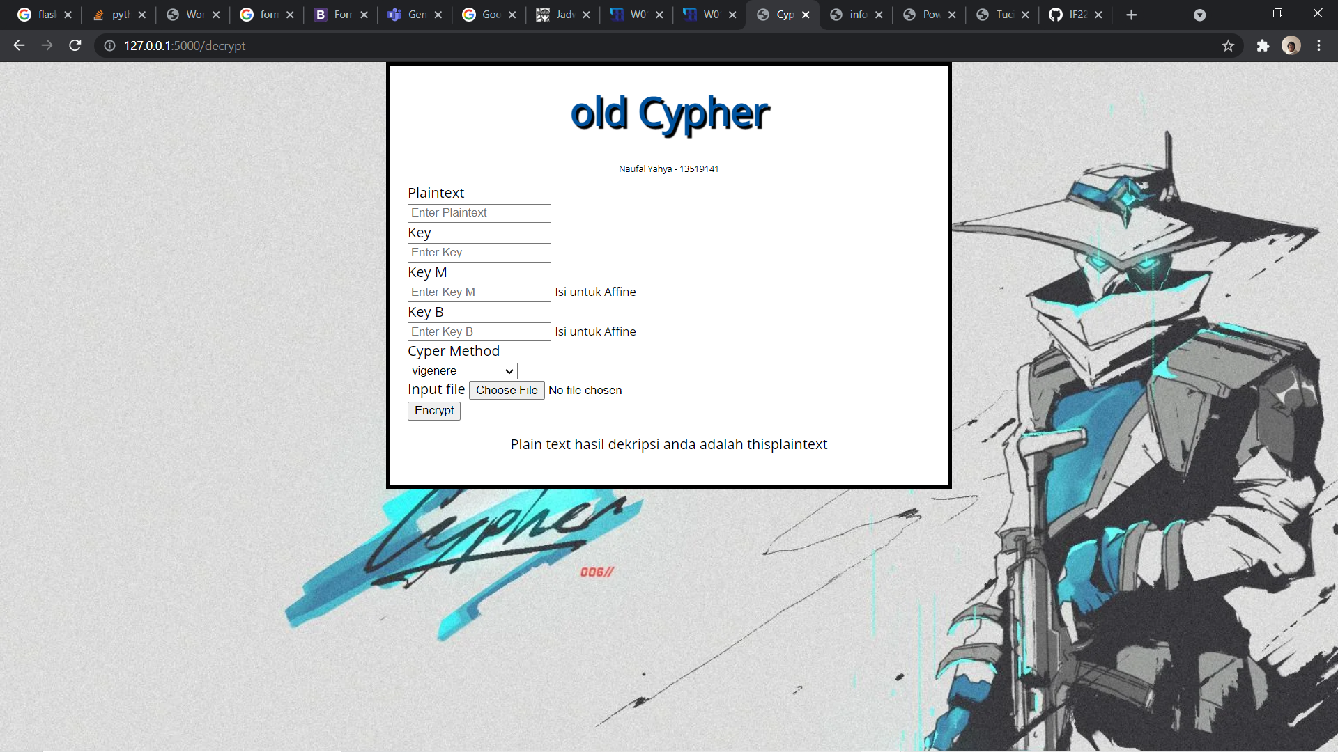

Mode Encrypt

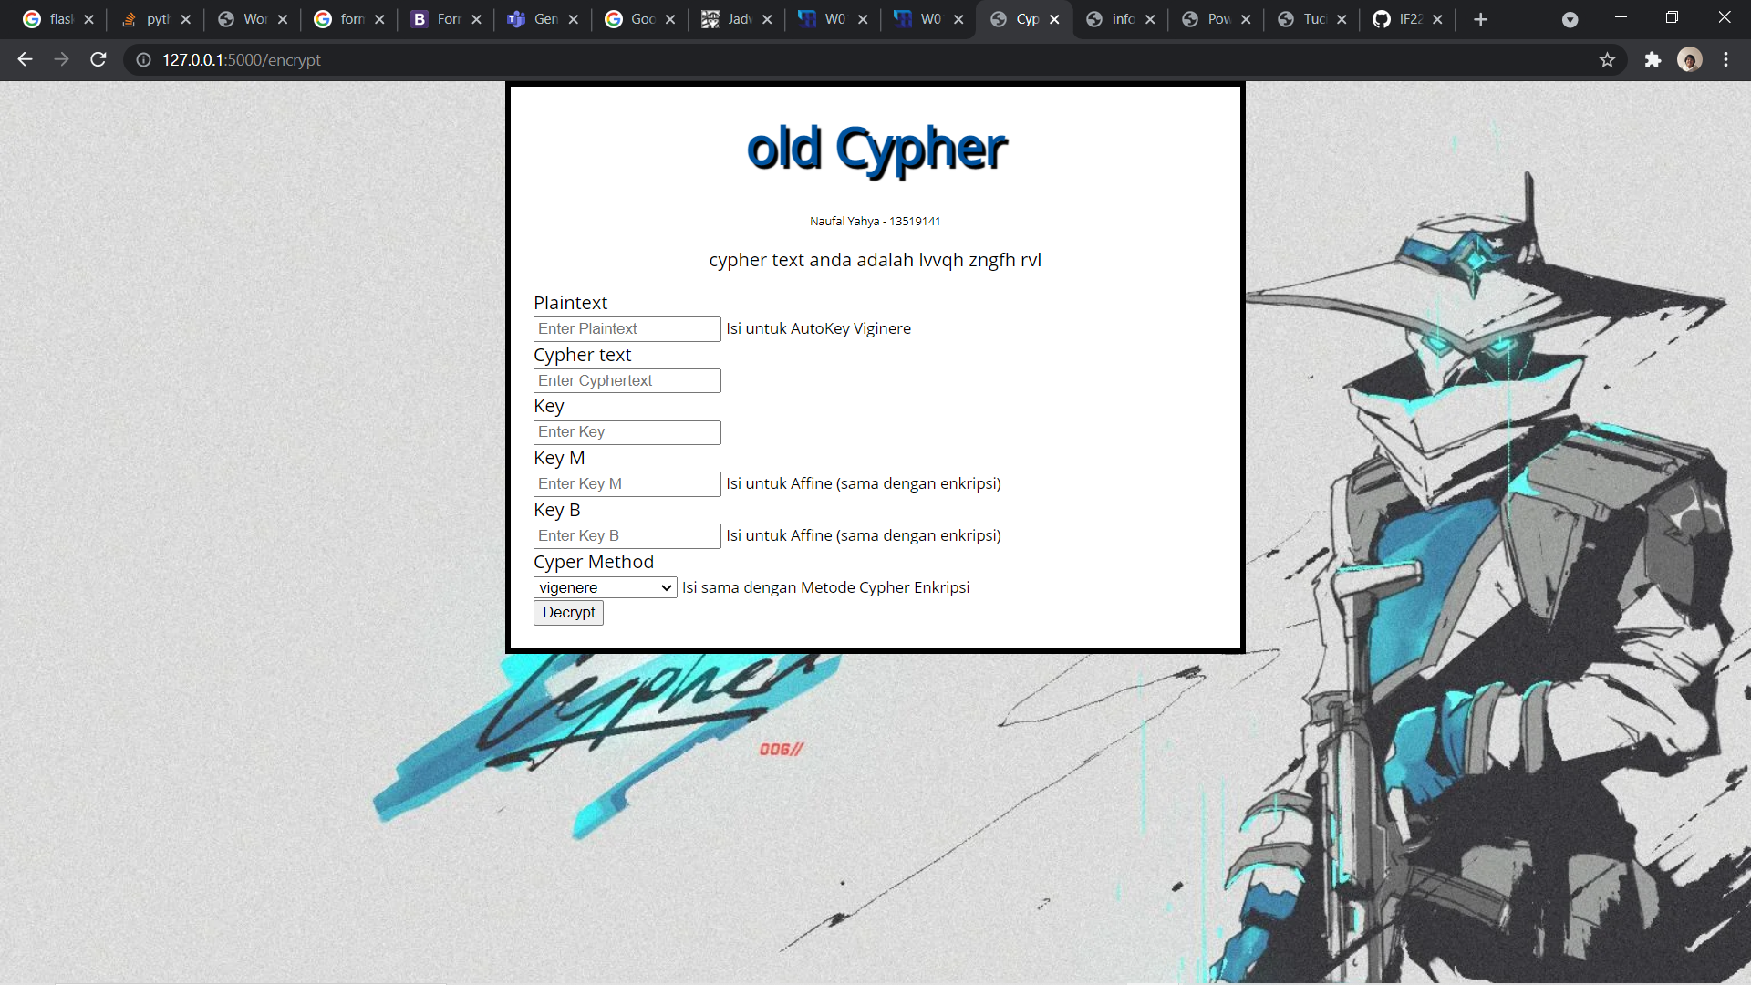

1. Cuplikan Penggunaan

File txt yang akan digunakan ada 2 jenis, untuk affine dan untuk sisanya. Tidak ada file biner karena extended vigenere tidak selesai. Berikut 2 file txt yang ada.

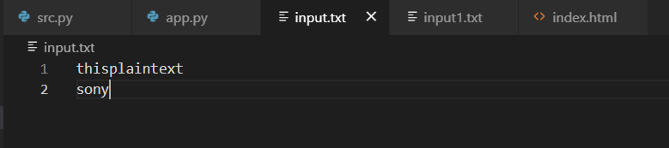

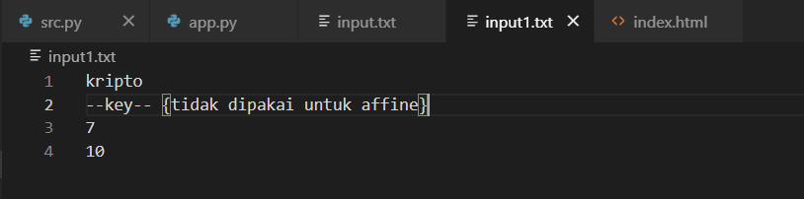

Vigenere Cypher

Sebelum Enkripsi -

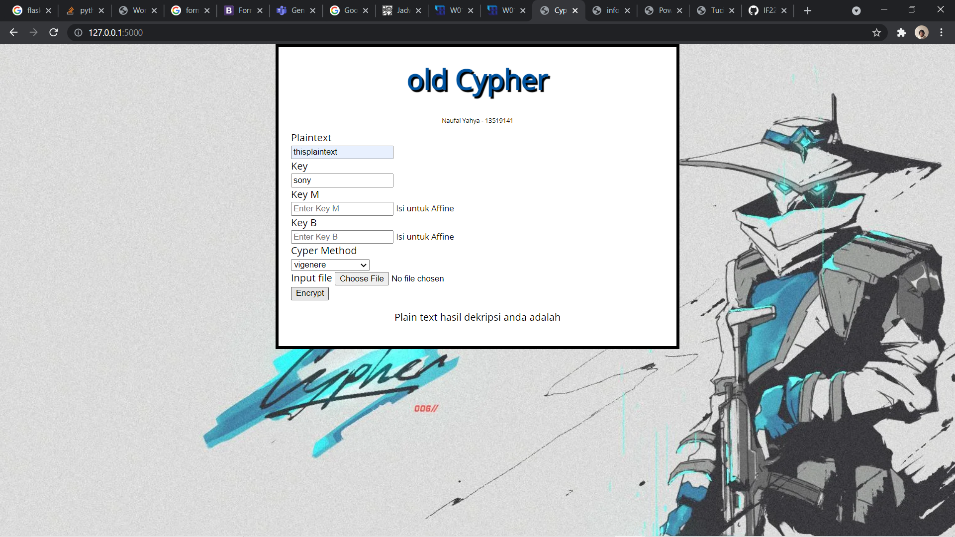

Setelah Enkripsi -

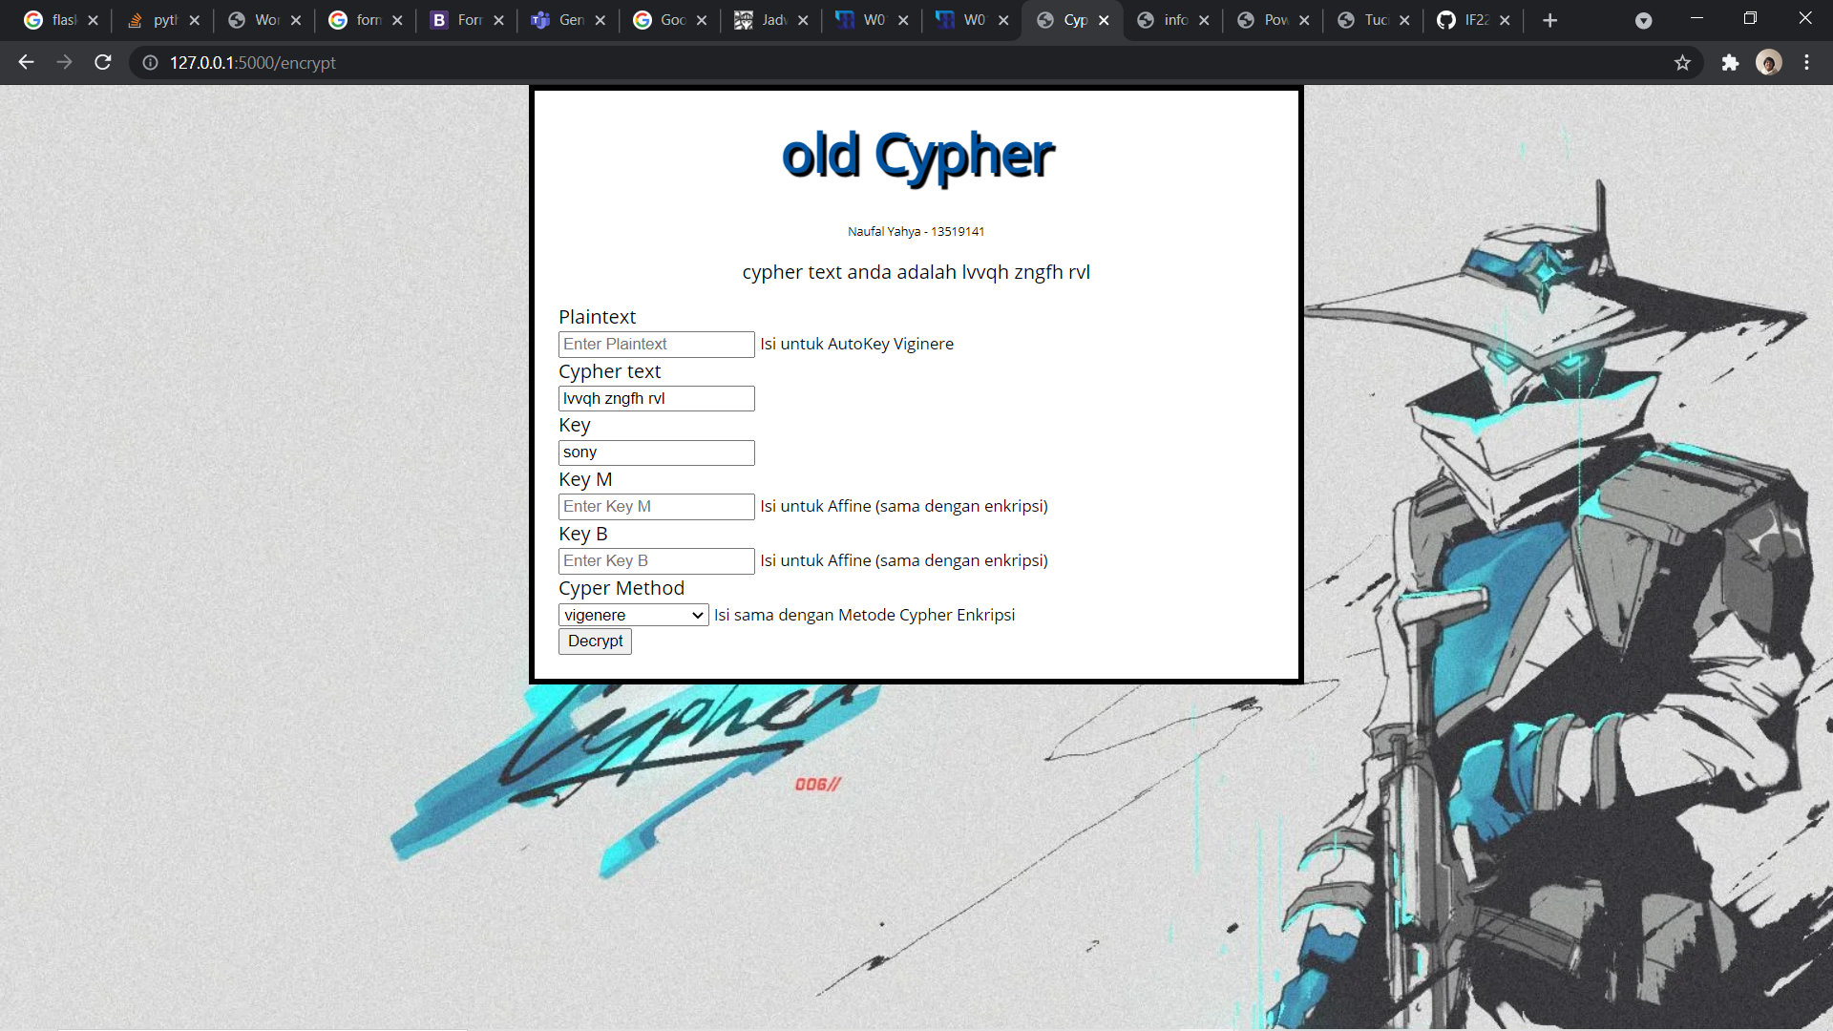

Setelah Dekripsi –

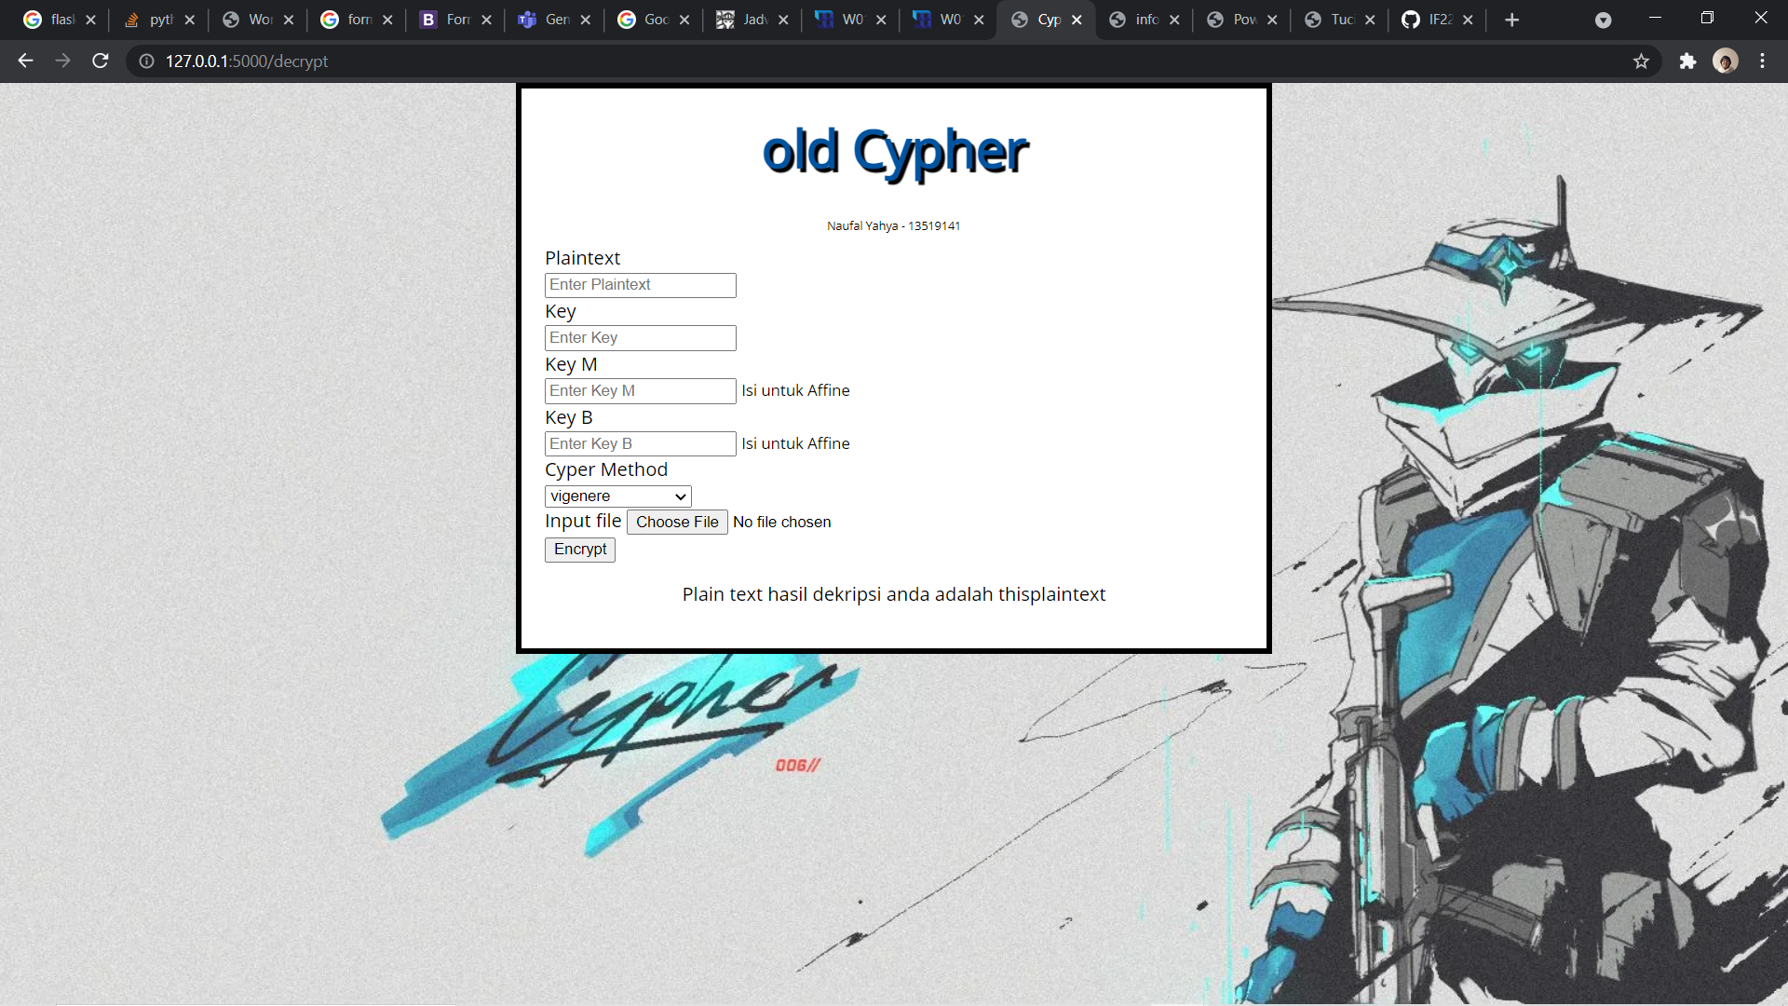

Menggunakan File

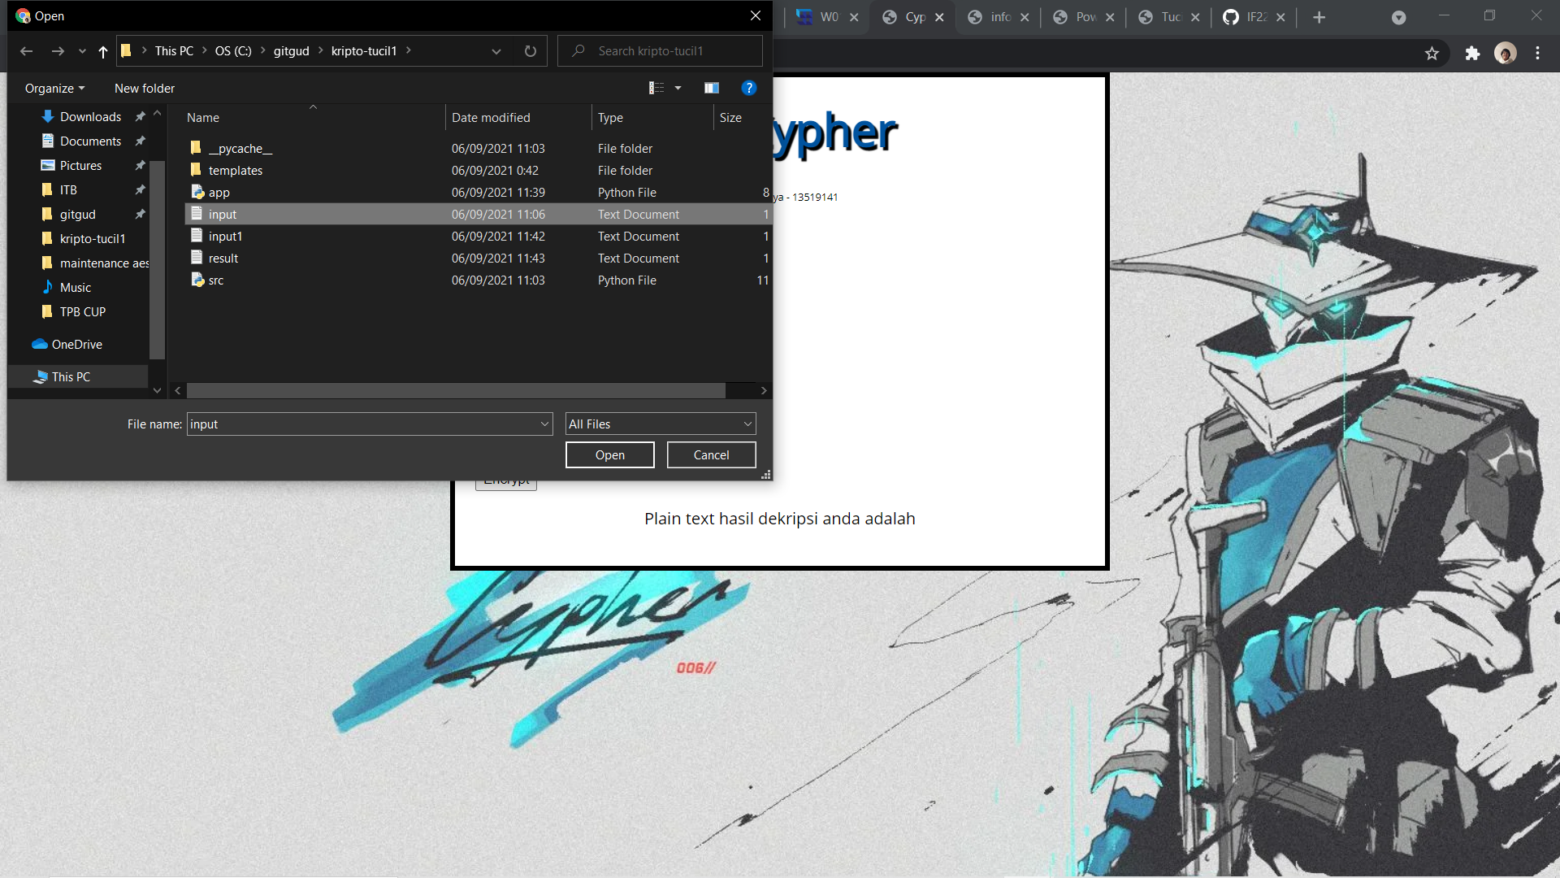

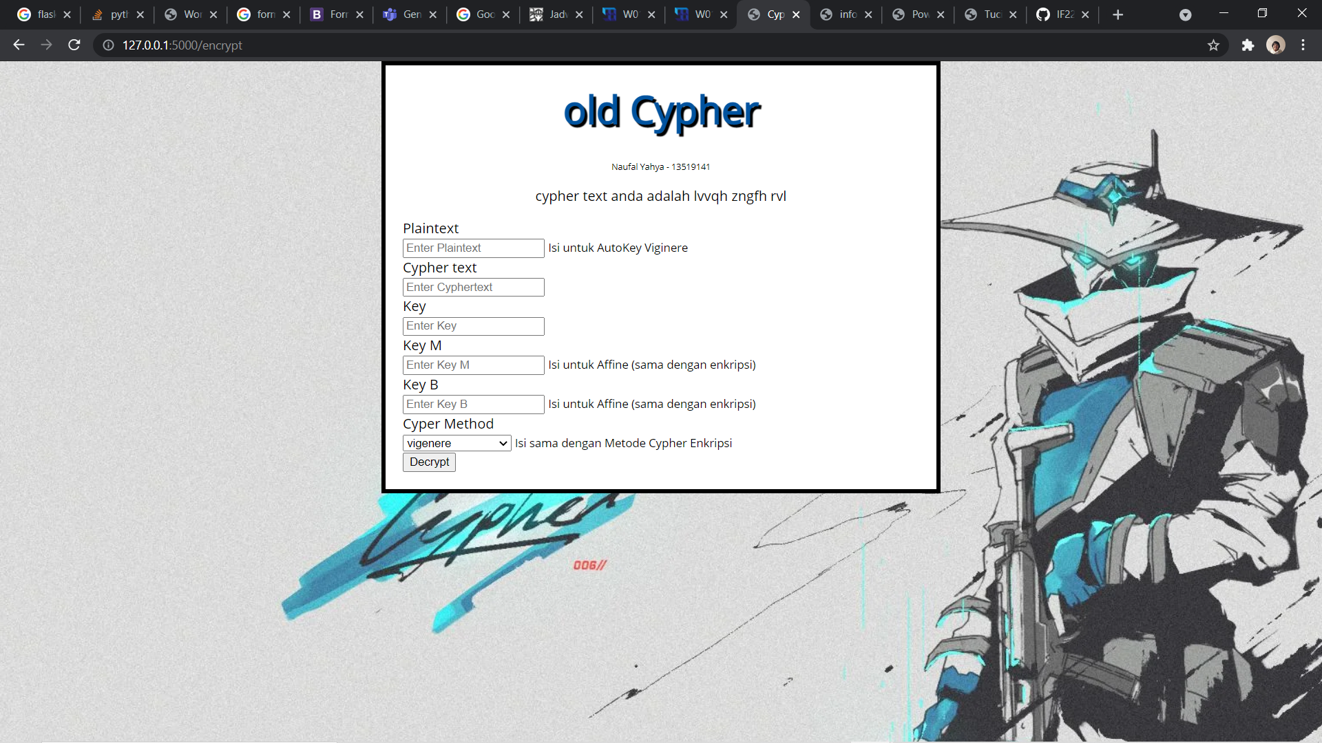

Hasil keluaran dapat disimpan dalam file

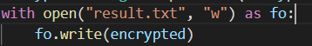

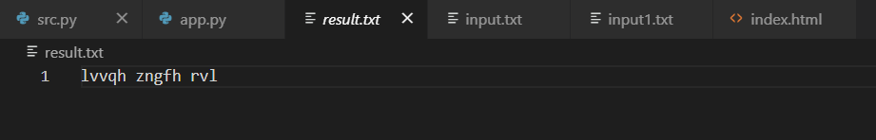

Full Vigenere Cypher

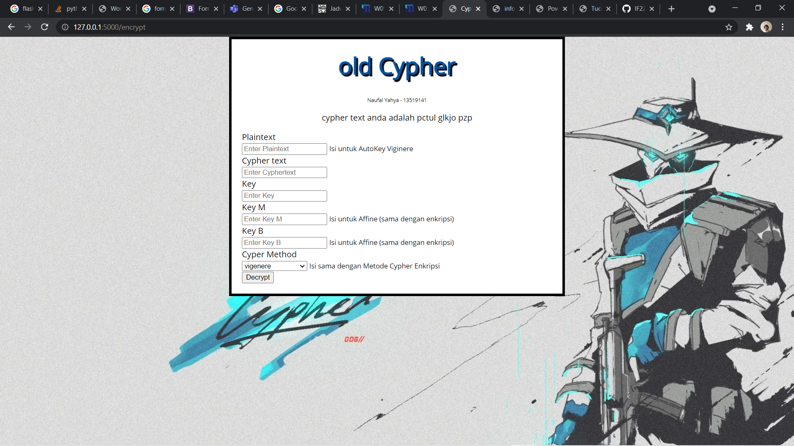

Sebelum dekripsi dan setelah dekripsi.



Menggunakan File

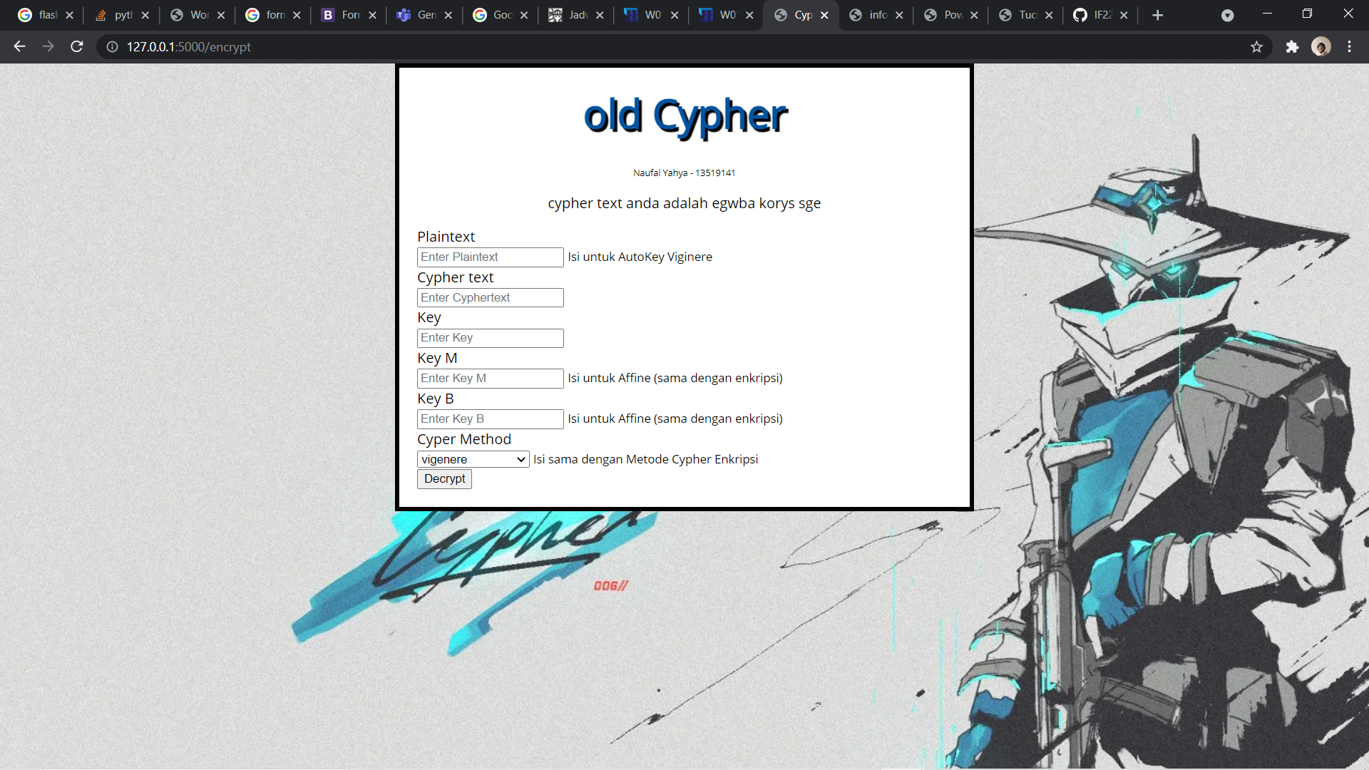

Sebelum dekripsi dan setelah dekripsi



AutoKey Viginere

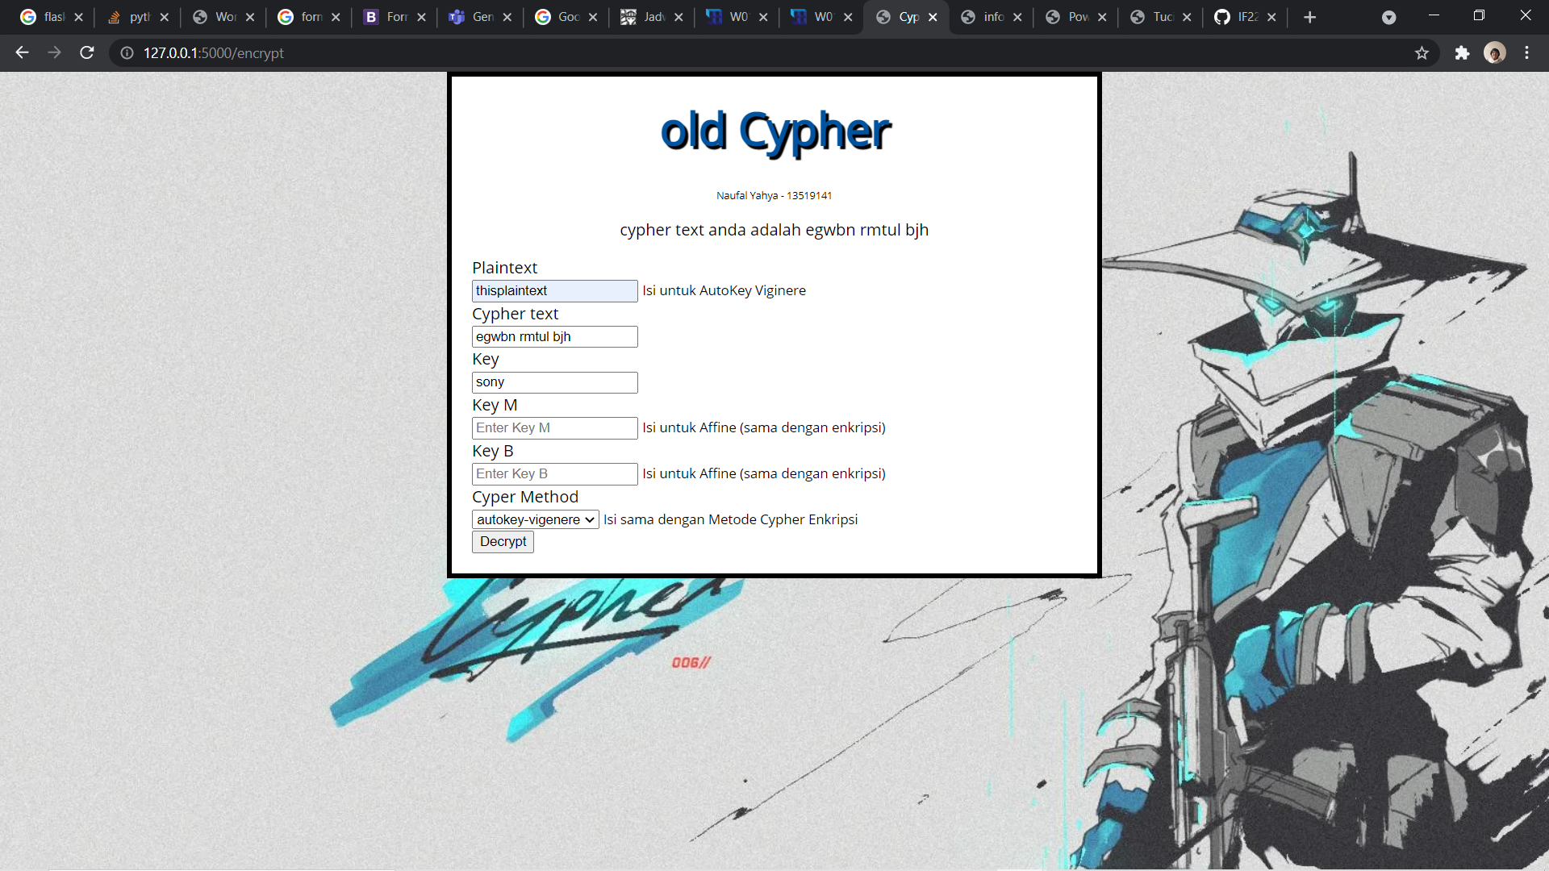

Sebelum dekripsi dan setelah dekripsi



Playfair

Input playfair adalah temui ibu nanti malam, menggunakan key mentah jalan ganesha sepuluh

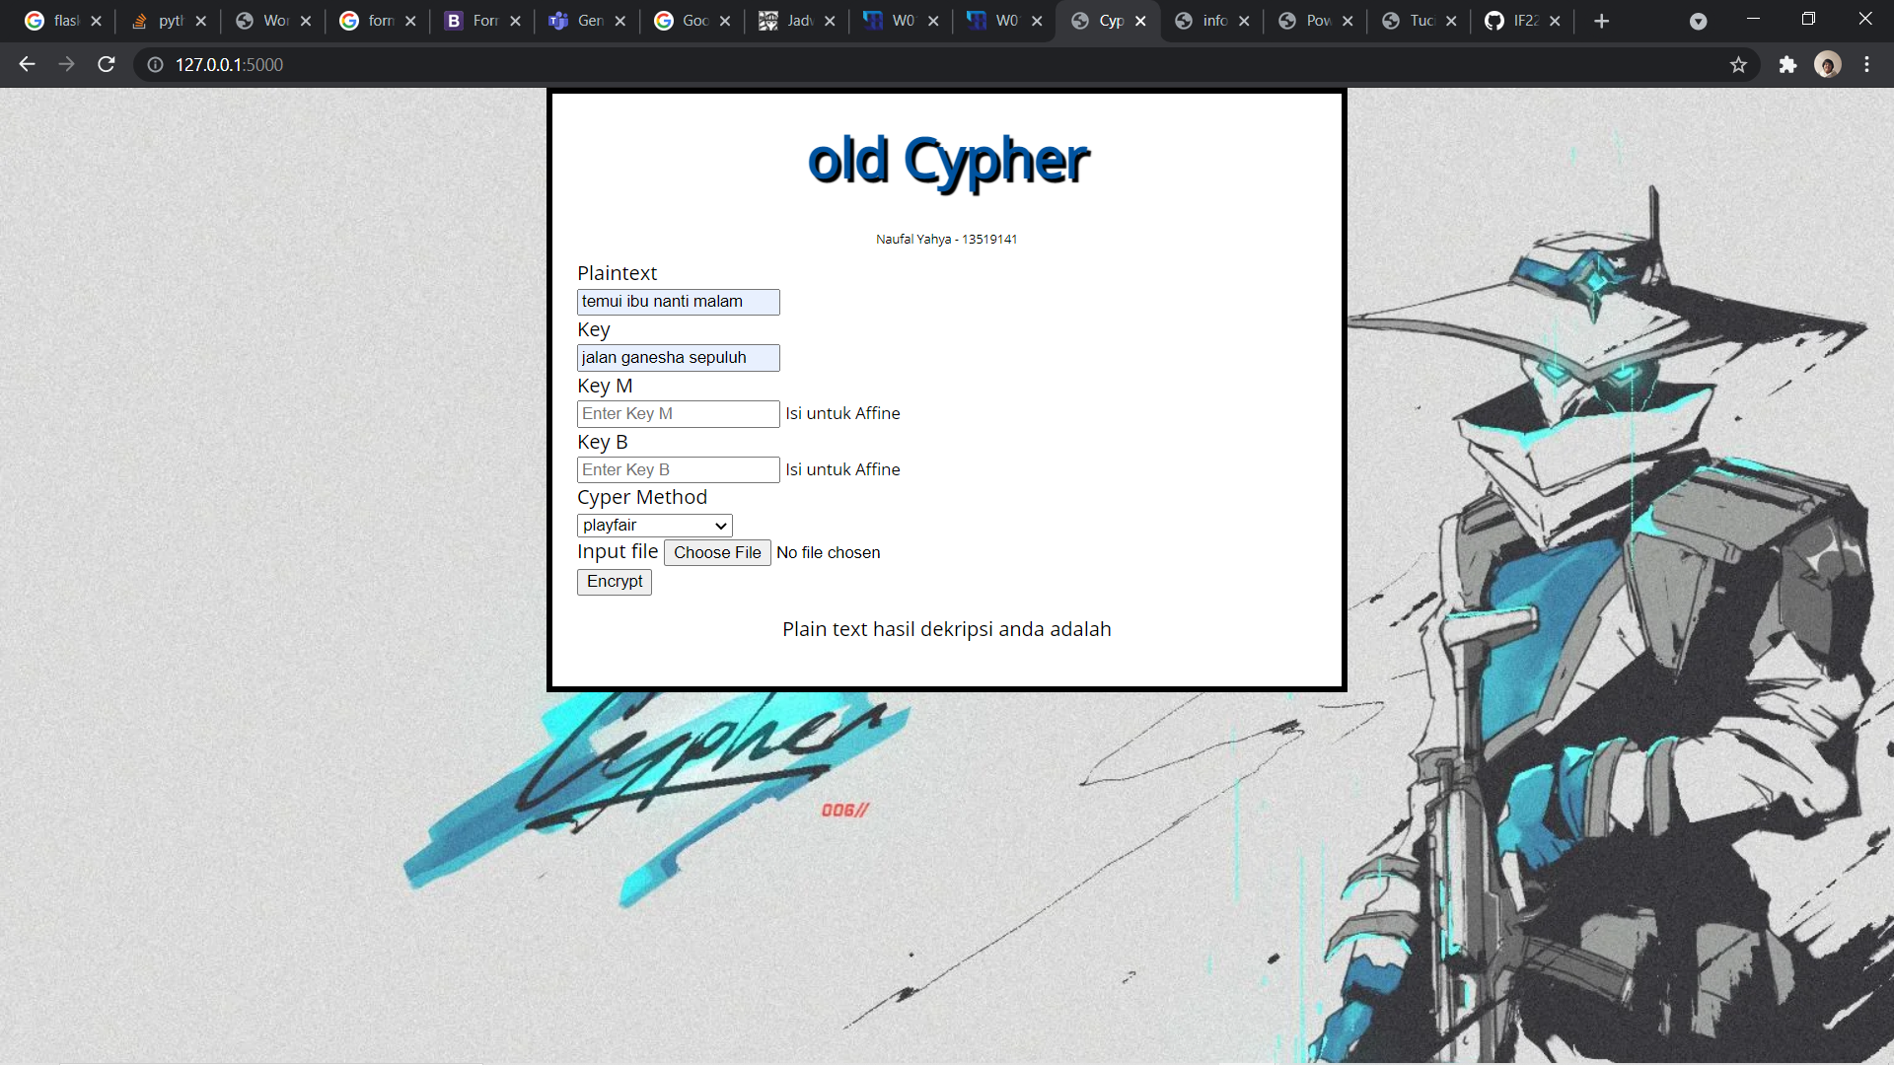

Sebelum dan Setelah Enkripsi

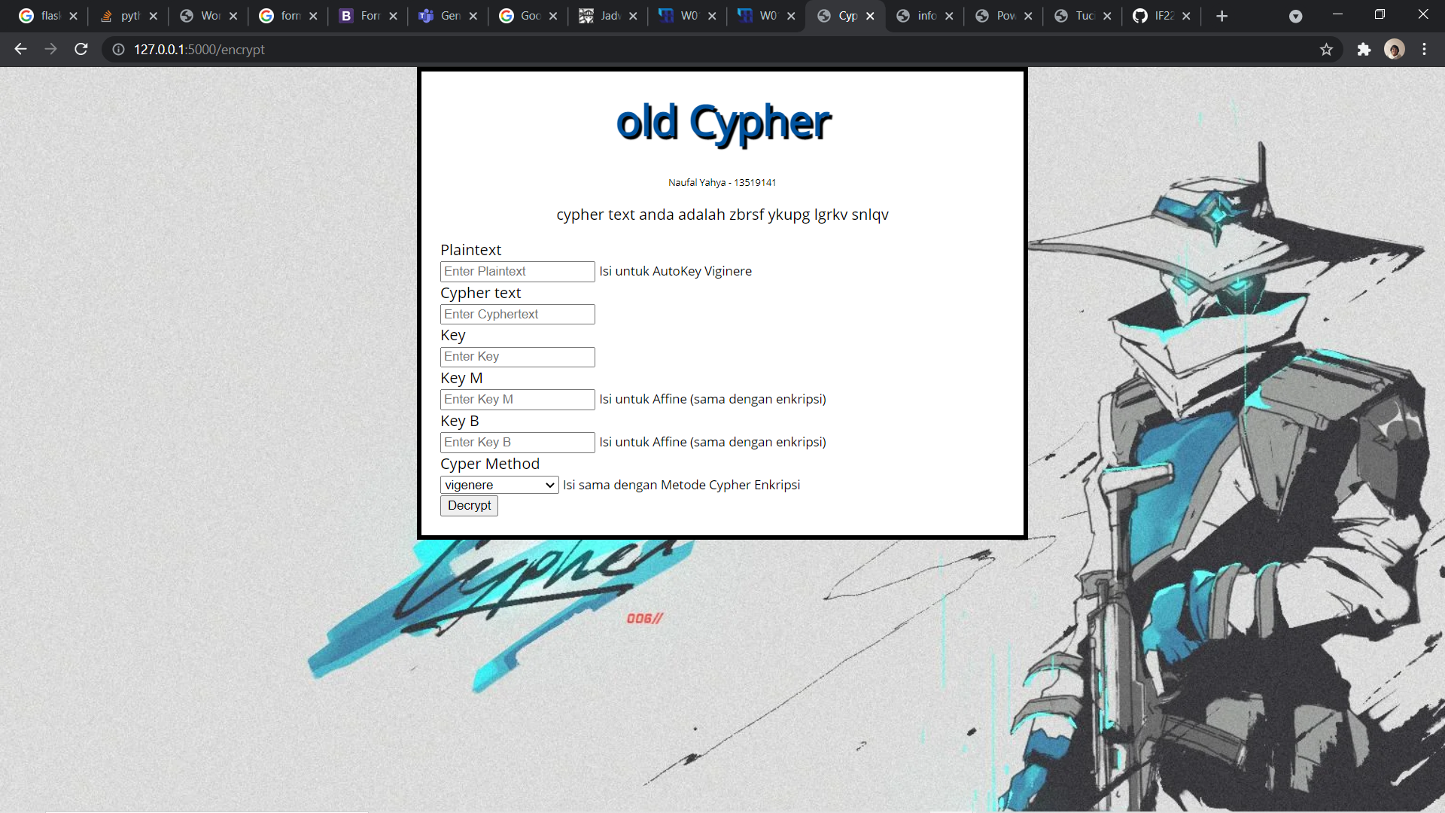

Setelah Dekripsi

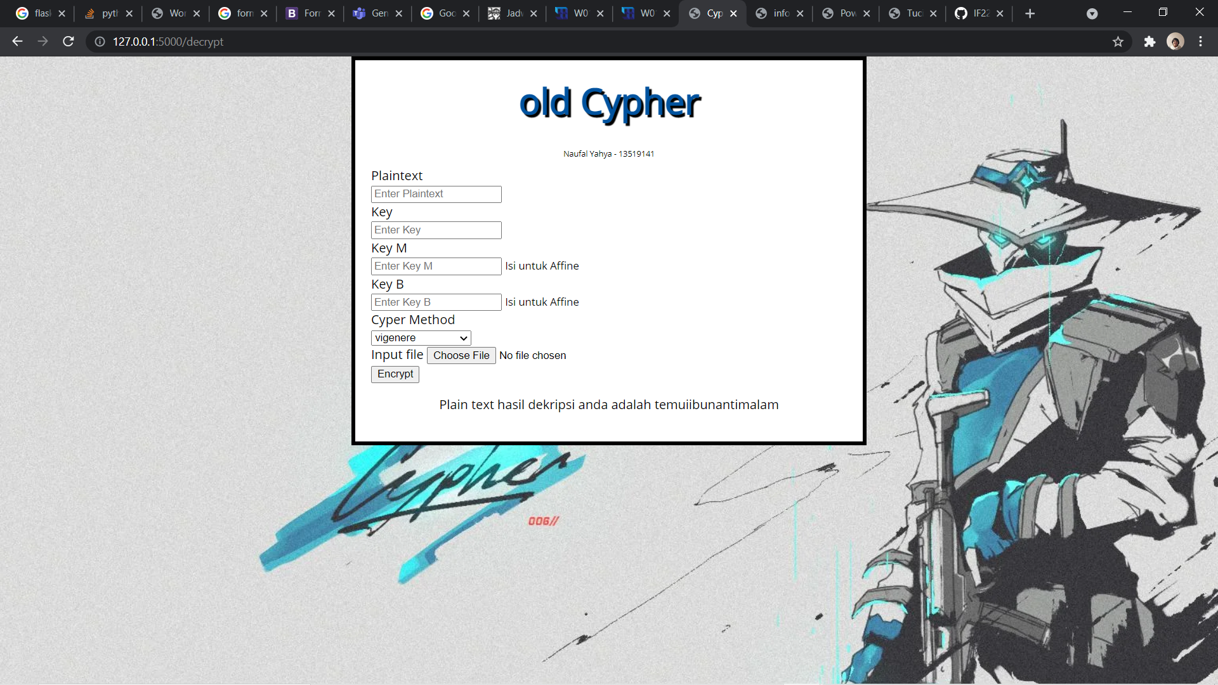

Affine

Sebelum dan Setelah Enkripsi

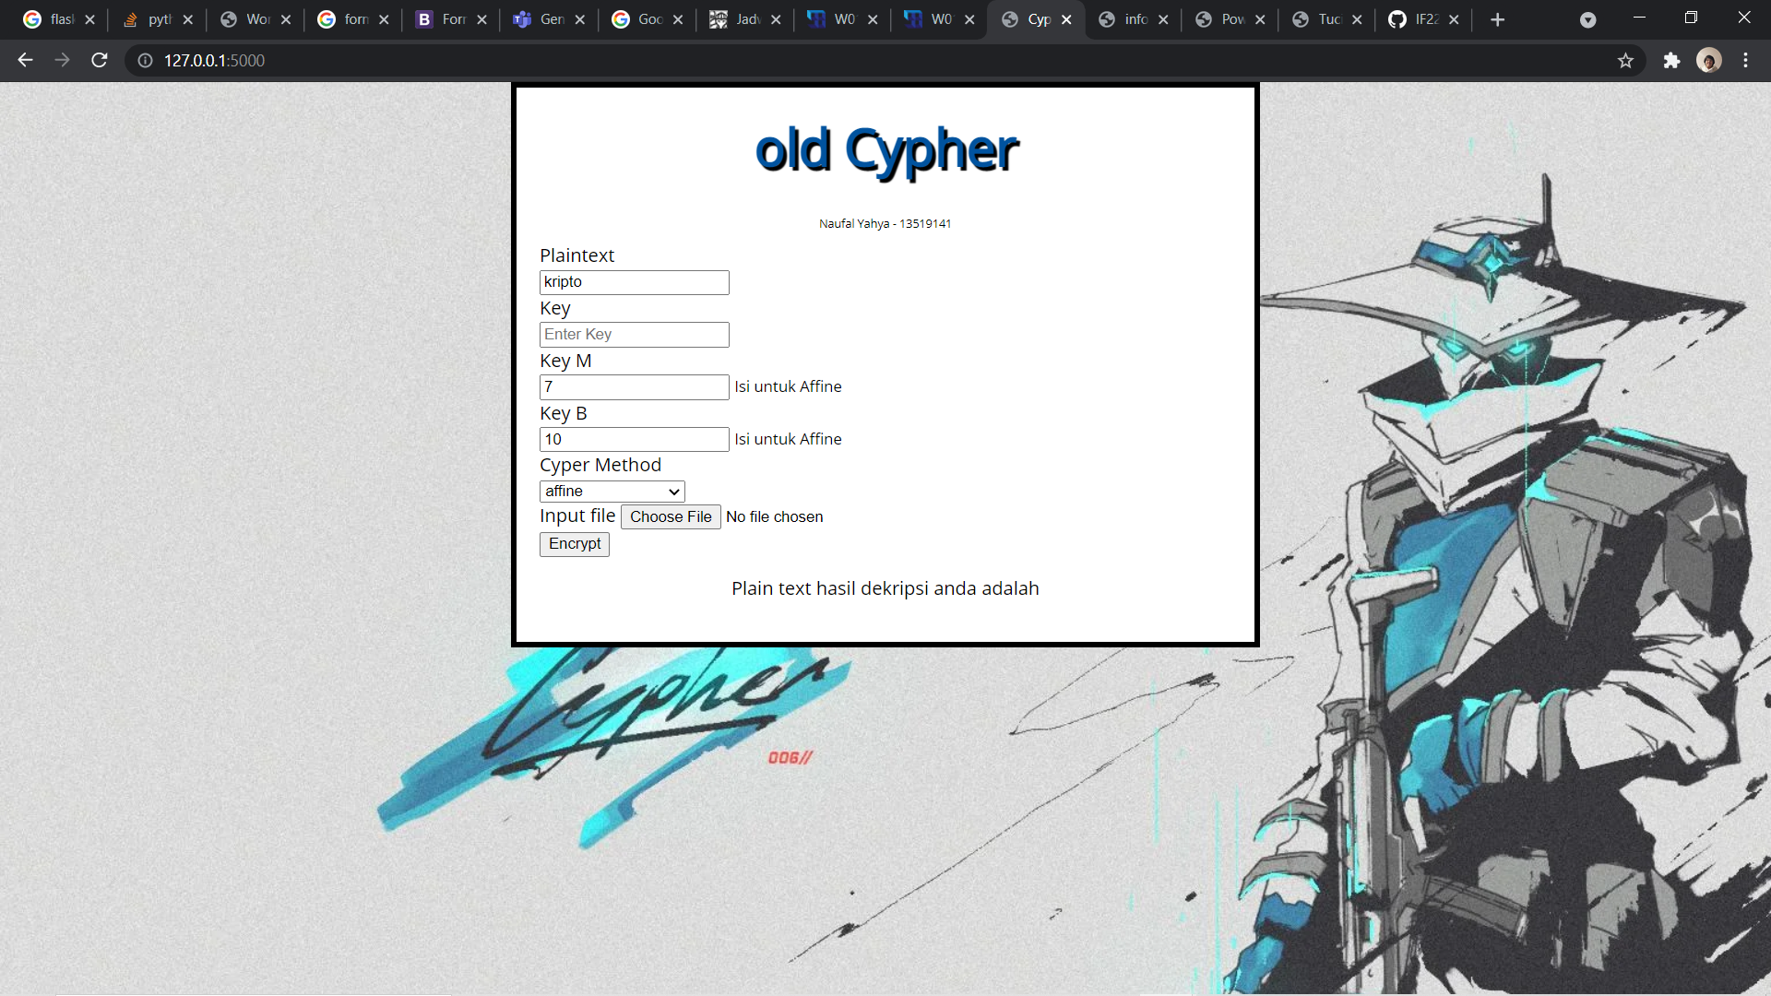

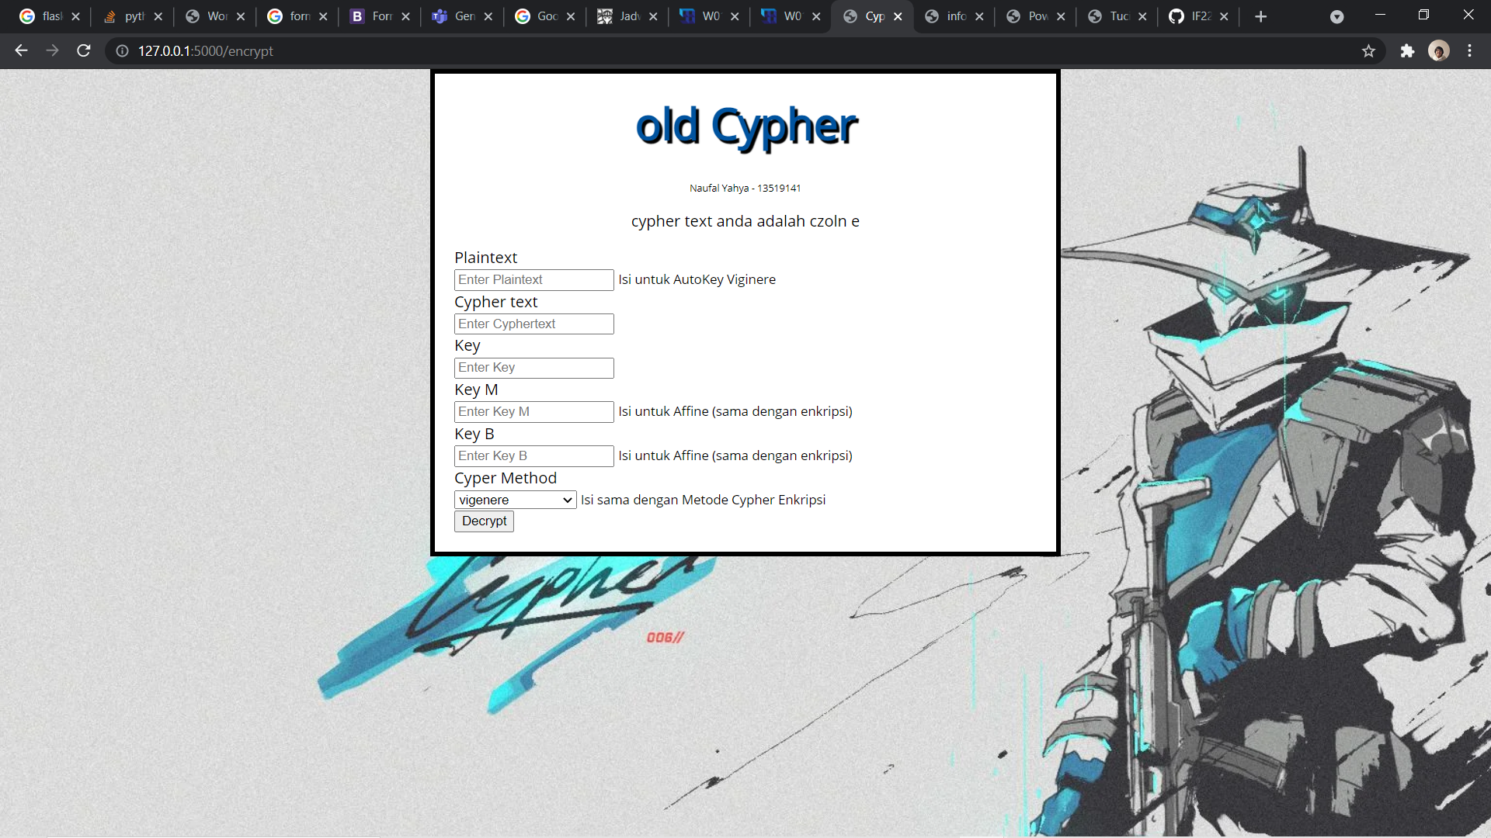

Sebelum dan Setelah Dekripsi

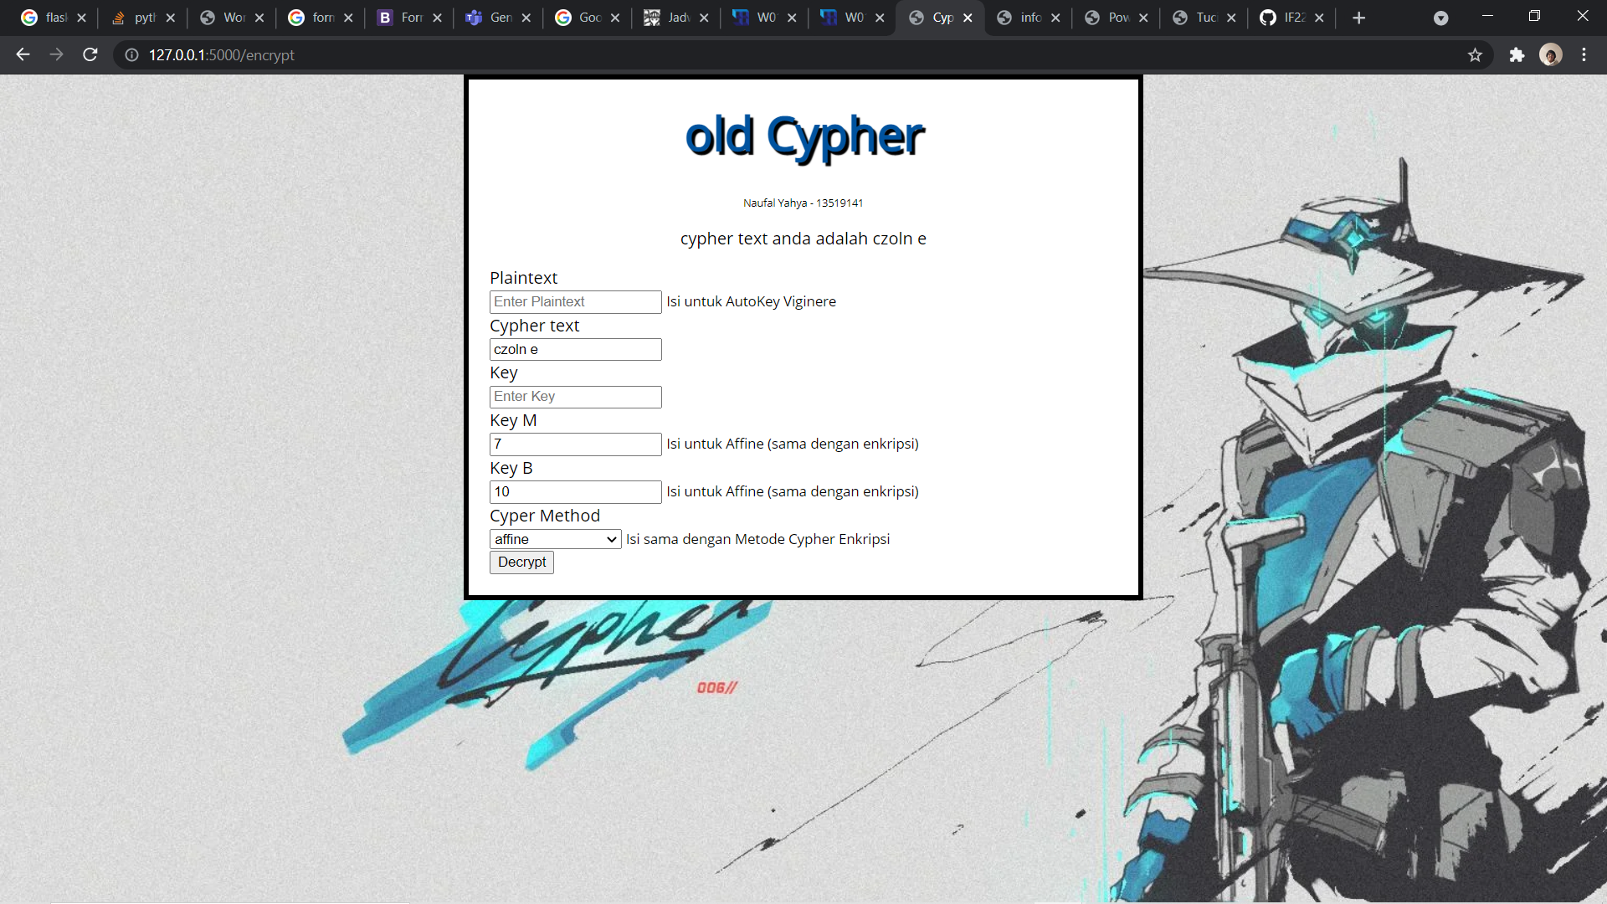

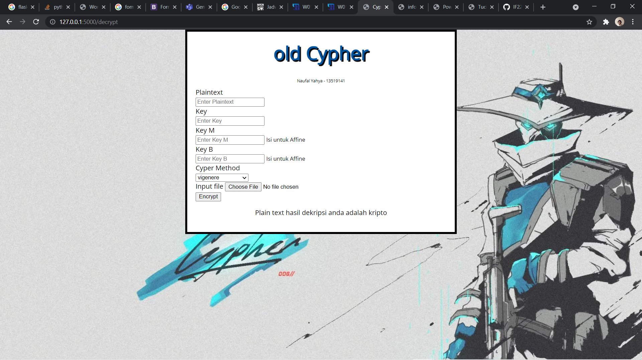

Menggunakan File

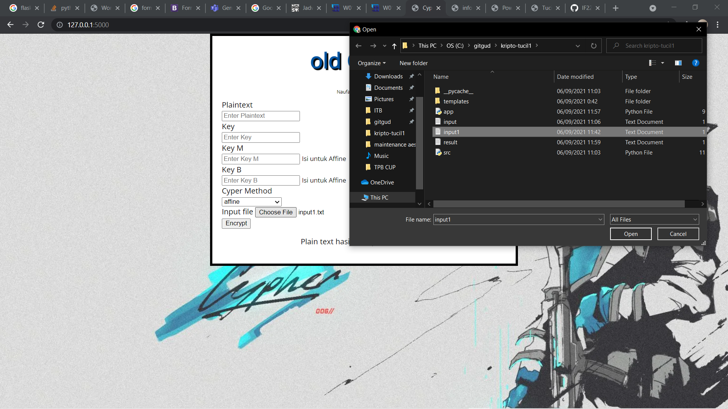

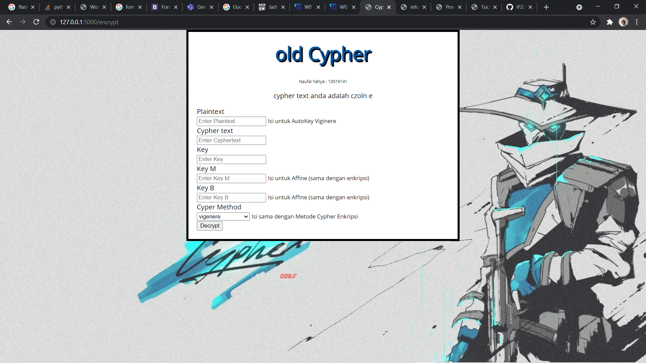

Hasil di result.txt

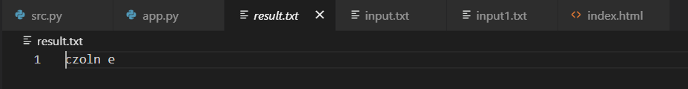

1. Tabel Penyelesaian

|  |  |  |  |  |
| --- | --- | --- | --- | --- |
| No | Spek | Berhasil | Kurang Berhasil | Keterangan |
| 1. | Vigenere | v |  |  |
| 2. | Full Vigenere | v |  |  |
| 3. | Auto-key Vigenere | v |  |  |
| 4. | Extended Vigenere |  | v | Tidak selesai |
| 5. | Playfair | v |  |  |
| 6. | Affine | v |  |  |
| 7. | Bonus |  | v | Tidak mengerjakan |

1. Link Github